**RE-FORESTATION USING ROBOTIC VEHICLE**

## A PROJECT REPORT

## *Submitted by,*

**Ms. NANDINI R - 20211CIT0070**

**Ms. REDDY SREYA -20211CIT0101**

**Ms. CHANDANA K -20211CIT0106**

**Ms. VINUTHA V -20211CIT0153**

### *Under the guidance of,*

**Dr. Anandaraj S P**

***in partial fulfillment for the award of the degree of***

**BACHELOR OF TECHNOLOGY**

**IN**

**COMPUTER SCIENCE AND ENGINEERING (INTERNET OF THINGS )**

**At**



**PRESIDENCY UNIVERSITY**

**BENGALURU**

**DECEMBER 2024**

**PRESIDENCY UNIVERSITY**

**SCHOOL OF COMPUTER SCIENCE ENGINEERING**

**CERTIFICATE**

This is to certify that the Project report **“Re-forestation using robotic vehicle”** being submitted by “NANDINI R”, “REDDY SREYA” ,“CHANDANA K” , “VINUTHA V” bearing roll number(s) “20211CIT0070” , “20211CIT0101” , “20211CIT0106” , “20211CIT0153” in partial fulfillment of the requirement for the award of the degree of Bachelor of Technology in Computer Science and Engineering (IOT) is a bonafide work carried out under my supervision.

|  |  |
| --- | --- |
| **Mr. E Sakthivel**  Assistant Professor  School of CSE  Presidency University | **Dr. Anandaraj S P**  HOD (CCS,CIT)  School of CSE  Presidency University |

|  |  |  |
| --- | --- | --- |
| **Dr. L. SHAKKEERA**  Associate Dean  School of CSE  Presidency University | **Dr. MYDHILI NAIR**  Associate Dean  School of CSE  Presidency University | **Dr. SAMEERUDDIN KHAN**  Pro-Vc School of Engineering  Dean -School of CSE&IS  Presidency University |

**PRESIDENCY UNIVERSITY**

**SCHOOL OF COMPUTER SCIENCE ENGINEERING**

**DECLARATION**

We hereby declare that the work, which is being presented in the project report entitled **RE-FORESTATION USING ROBOTIC VEHICLE** in partial fulfillment for the award of Degree of **Bachelor of Technology in Computer Science and Engineering**, is a record of our own investigations carried under the guidance of **Mr. E Sakthivel**

**Assistant Professor , School of Computer Science Engineering & Information Science, Presidency University, Bengaluru.**

We have not submitted the matter presented in this report anywhere for the award of any other Degree.

|  |  |
| --- | --- |
|  | **NANDINI R - 20211CIT0070**  **REDDY SREYA -20211CIT0101**  **CHANDANA K -20211CIT0106**  **VINUTHA V -20211CIT0153** |

**ABSTRACT**

Studies on automatic agriculture robot car is a critical thing of advancing the agriculture enterprise, mainly in India, wherein agriculture serves because the backbone of the financial system and extensively contributes to GDP. This paper introduces a novel approach to development of Re-forestation the use of robotic vehicle integrated with software and hardware components. This primary intention of this studies is to enhance the productivity and sustainability in reforestation practices by using leveraging advanced technologies like a robot automobile and system gaining knowledge of Algorithms. Centered on technology elements of agriculture, this research paper presents an integrated device including two predominant functionalities: 1) robotic automobile that plays numerous farming activities that help farmers including ploughing, sowing , irrigation. 2)Crop prediction the usage of live sensors which include temperature , soil moisture and atmospheric stress .The vegetation are expected the usage of the records sensed via those sensors and use machine studying .Algorithms trained on historical discipline data. Moreover this research paintings allows the amateur farmer in sowing the adaptive crop lowering the person electricity, enhances planting precision through computerized planting system and reduces the possibilities of crop failures through crop advice gadget. finally the approach observed on this indicates outstanding potential for automating the farming practices and crop prediction. In fact, the test became finished at the rice and wheat crops established the effectiveness of the proposed approach, and the same method may be used on different vegetation to acquire the equal purpose. looking ahead, this research gives insights into further traits of automating forest management, correct yield prediction of advocated crop, and retaining the ecological stability.

*Keywords—* *• Automatic agriculture robot, Reforestation, ,Self-driven vehicle, Farming activities Crop prediction, Machine learning algorithms , Sustainability*

**ACKNOWLEDGEMENT**

First of all, we indebted to the **GOD ALMIGHTY** for giving me an opportunity to excel in our efforts to complete this project on time. We express our sincere thanks to our respected dean **Dr. Md. Sameeruddin Khan,** Pro-VC, School of Engineering and Dean, School of Computer Science Engineering & Information Science, Presidency University for getting us permission to undergo the project.

We express our heartfelt gratitude to our beloved Associate Deans **Dr. Shakkeera L** and **Dr. Mydhili Nair**, School of Computer Science Engineering & Information Science, Presidency University, and Dr. “Anandaraj S P”, Head of the Department, School of Computer Science Engineering & Information Science, Presidency University, for rendering timely help in completing this project successfully.

We are greatly indebted to our guide **Dr. Anandaraj S P, HOD (CCS-CIT)** and Reviewer Mr. **Sakthivel , Assistant Professor** , School of Computer Science Engineering & Information Science, Presidency University for his inspirational guidance, and valuable suggestions and for providing us a chance to express our technical capabilities in every respect for the completion of the project work.

We would like to convey our gratitude and heartfelt thanks to the PIP2001 Capstone Project Coordinators **Dr. Sampath A K, Dr. Abdul Khadar A and Mr. Md Zia Ur Rahman**, department Project Coordinators “Dr Sharmasth Vali Y” and Git hub coordinator **Mr. Muthuraj.**

We thank our family and friends for the strong support and inspiration they have provided us in bringing out this project.

**NANDINI R**

**REDDY SREYA**

**CHANDANA K**

**VINUTHA V**

**LIST OF TABLES**

|  |  |  |  |
| --- | --- | --- | --- |
| **Sl. No.** | **Table Name** | **Table Caption** | **Page No.** |
| 1 | Table 1.1 | Crop Recommendation Criteria | 36 |

**LIST OF FIGURES**

|  |  |  |  |
| --- | --- | --- | --- |
| **Sl. No** | **Figure Name** | **Caption** | **Page No** |
| 1 | Fig 1 | Features of agriculture robot | 20 |
| 2 | Fig 2 | Flow chart of the steps followed by the robot | 35 |
| 3 | Fig 3 | System implementation and design | 40 |
| 4 | Fig 4 | Gantt Chart | 44 |

|  |  |  |  |
| --- | --- | --- | --- |
|  |  |  |  |
|  |  |  |  |

**TABLE OF CONTENT**

|  |  |  |  |  |  |  |  |  |  |  |  |  |  |  |  |  |  |  |  |  |  |  |  |  |  |  |  |  |  |  |  |  |  |  |  |  |  |  |  |  |  |  |  |  |  |  |  |  |  |  |  |  |  |  |  |  |  |  |  |  |  |  |  |  |  |  |  |  |  |  |  |  |  |  |  |  |  |  |  |  |  |  |  |  |  |  |  |  |  |  |  |  |  |  |  |  |  |  |  |  |  |  |  |  |  |  |  |  |  |  |  |  |  |  |  |  |  |  |  |  |  |  |  |  |  |  |  |  |  |  |  |  |  |  |  |  |  |  |  |  |  |  |  |  |  |  |  |  |  |  |  |  |  |  |  |  |  |  |  |  |  |  |  |  |  |  |  |  |  |  |  |  |  |  |  |  |  |  |  |  |  |  |  |  |  |  |  |  |  |  |  |  |  |  |  |  |  |  |
| --- | --- | --- | --- | --- | --- | --- | --- | --- | --- | --- | --- | --- | --- | --- | --- | --- | --- | --- | --- | --- | --- | --- | --- | --- | --- | --- | --- | --- | --- | --- | --- | --- | --- | --- | --- | --- | --- | --- | --- | --- | --- | --- | --- | --- | --- | --- | --- | --- | --- | --- | --- | --- | --- | --- | --- | --- | --- | --- | --- | --- | --- | --- | --- | --- | --- | --- | --- | --- | --- | --- | --- | --- | --- | --- | --- | --- | --- | --- | --- | --- | --- | --- | --- | --- | --- | --- | --- | --- | --- | --- | --- | --- | --- | --- | --- | --- | --- | --- | --- | --- | --- | --- | --- | --- | --- | --- | --- | --- | --- | --- | --- | --- | --- | --- | --- | --- | --- | --- | --- | --- | --- | --- | --- | --- | --- | --- | --- | --- | --- | --- | --- | --- | --- | --- | --- | --- | --- | --- | --- | --- | --- | --- | --- | --- | --- | --- | --- | --- | --- | --- | --- | --- | --- | --- | --- | --- | --- | --- | --- | --- | --- | --- | --- | --- | --- | --- | --- | --- | --- | --- | --- | --- | --- | --- | --- | --- | --- | --- | --- | --- | --- | --- | --- | --- | --- | --- | --- | --- | --- | --- | --- | --- | --- | --- | --- | --- | --- | --- |
| |  |  |  | | --- | --- | --- | | **Chapter No.** | **Title** | **Page No.** | | I | CERTIFICATE | ii | | II | DECLARATION | iii | | III | ABSTRACT | iv | | IV | ACKNOWLEDGEMENT | v | | V | LIST OF TABLES | vi | | VI | LIST OF FIGURES | vii | | 1 | INTRODUCTION | 1 | |  | 1.1 Description | 1-9 | |  | 1.2 Technology used | 10 | |  | 1.3 Goals | 10 | |  | 1.4 Industrial scope | 10-11 | | 2 | LITERATURE SURVEY | 12-16 | | 3 | RESEARCH GAPS OF EXISTING METHODS | 17 | |  | 3.1 Limitations in Current Technological Advancements in Agriculture | 17-19 | |  | 3.2 Urban Garden Focus and Scalability Issues | 19 | |  | 3.3 Inadequate Integration of Advanced Analysis Techniques | 20 | |  | 3.4 Absence of Real-Time Data Integration | 20 | |  | 3.5 Limitations in Sensor-Based Monitoring | 21 | |  | 3.6 Over-Reliance on Historical Data | 21 | |  | 3.7 Path Forward | 22 | |  | 3.8 Integrated Multifunctional Systems | 22 | |  | 3.9 Adaptability to Diverse Soil Types and Terrains | 22 | |  | 3.10 Advanced Analytical Techniques | 22-23 | |  | 3.11 Real-Time Sensor Integration and Monitoring | 23 | |  | 3.12 Promoting Sustainability and Resilience | 23 | | 4 | PROPOSED MOTHODOLOGY | 24 | |  | 4.1 Reforestation Robotic Vehicle: The Hardware Backbone | 24 | |  | 4.2 Precision in Planting and Maintenance | 25 | |  | 4.3 Sensor Integration for Real-Time Environmental Monitoring | 25-26 | |  | 4.4 Data Management and Remote Control via Blynk App | 26 | |  | 4.5 Expanding Applications for Agriculture and Reforestation | 27 | | 5 | OBJECTIVES | 28 | |  | * 1. Design and Development | 28 | |  | 5.2 Reafforestation-Specific Objectives | 28 | |  | 5.3 Crop Prediction and Decision Support | 28 | |  | 5.4 Evaluation and Refinement: | 29 | |  | 5.5 Dissemination and Knowledge Transfer: | 29 | | 6 | SYSTEM DESIGN & IMPLEMENTATION | 30-33 | | 7 | TIMELINE FOR EXECUTION OF PROJECT | 34-35 | | 8 | OUTCOMES | 36 | |  | 8.1 Better productivity and Sustainability | 36 | |  | 8.2 Powerful Crop Prediction | 36 | |  | 8.3 Guide for novice Farmers | 36 | |  | 8.4 Automatic Farming Practices | 36 | |  | 8.5 Successful checking out on Rice and Wheat plants | 36 | |  | 8.6 Insights for destiny traits | 37 | |  | 8.7 Ecological and monetary advantages | 37 | | 9 | RESULTS AND DISCUSSIONS | 38 | |  | 9.1 Automation of Agricultural Operations | 38 | |  | 9.2 Real-Time Environmental Monitoring for Resource Optimization | 38-39 | |  | 9.3 Sustainability and Resource Efficiency | 39 | |  | 9.4 Real-Time Monitoring and User Interaction | 39-40 | |  | 9.5 Crop Recommendation and Yield Prediction | 40-41 | |  | 9.6 Technological Advancements and Component Efficiency | 41 | |  | 9.7 Implications for Modern Agriculture | 42 | |  | 9.8 Machine Learning Algorithms for Enhanced Functionality | 42 | |  | 9.9 Conclusion | 42-43 | | 10 | CONCLUSION | 44-45 | |  | REFERENCES | 46 | |  | APPENDIX-A (PSUEDOCODE ) | 47-48 | |  | APPENDIX-B (SCREENSHOTS) | 49-51 | |  | APPENDIX-C(ENCLOSURES) | 52-60 | |  |  |  | |  |  |  | |  |  |  | |

**CHAPTER-1**

**INTRODUCTION**

**1.1 DESCRIPTION**

Automated Agriculture Robotic Vehicle for Enhanced Reforestation Practices

The Automated Agriculture Robotic Vehicle represents a significant leap forward in addressing persistent challenges in agriculture and reforestation. Agriculture has always been central to human civilization, serving not only as a source of food but also as a foundation for societal development. In the context of India, the importance of agriculture is magnified, as it provides livelihoods for a vast majority of the population and plays a crucial role in the nation’s economy. Despite its pivotal role, the agricultural sector faces growing threats that endanger its sustainability and productivity. Climate change has led to unpredictable weather patterns, while the over-exploitation of natural resources has degraded soil fertility and reduced water availability. Additionally, rising pollution levels, pest infestations, and crop diseases further exacerbate these issues, leaving the sector in urgent need of technological innovation to secure its future.

In recent years, Robotics and Machine Learning (ML) have emerged as transformative forces across multiple domains, including agriculture. These technologies hold immense potential to address a wide range of challenges, from labour shortages and resource inefficiency to crop monitoring and environmental conservation. The agricultural sector, traditionally reliant on labour-intensive practices, often struggles with inefficiencies and outdated methodologies. Furthermore, a significant portion of agricultural issues stems from gaps in knowledge and the lack of accessible tools to guide farmers in decision-making processes. Technologies like robotics and ML offer a way to bridge these gaps by providing intelligent, data-driven solutions that improve productivity and promote sustainable practices.

The integrated system proposed in this research builds on these advancements by combining the physical capabilities of a self-driven robotic vehicle with the analytical power of machine learning algorithms. Together, these technologies aim to transform both farming and reforestation practices. The system’s design prioritizes three key objectives: improving crop yield prediction, delivering adaptive crop recommendations, and enabling large-scale reforestation through automation.

**Crop Yield Prediction**

One of the primary focuses of the proposed system is improving the accuracy of crop yield predictions. Accurate predictions allow farmers to anticipate harvest outcomes and make informed decisions about resource allocation, marketing strategies, and financial planning. The self-driven robotic vehicle collects vast amounts of environmental and soil data using an array of embedded sensors. Parameters such as soil moisture, nutrient content, temperature, and atmospheric pressure are continuously monitored to provide a comprehensive understanding of field conditions.

Machine learning algorithms analyze this data, identifying patterns and correlations that impact crop growth and productivity. By integrating historical agricultural data with real-time inputs, the system generates precise yield predictions. These insights empower farmers to adopt proactive strategies, such as adjusting irrigation schedules, modifying fertilizer application, or planting crops better suited to the prevailing conditions. The result is not only an increase in yield but also a reduction in wasted resources and an improvement in overall efficiency.

**Adaptive Crop Recommendation**

Another critical aspect of the system is its ability to recommend crops best suited to specific environmental and soil conditions. Farmers often face challenges in selecting the right crops for cultivation due to insufficient knowledge of local conditions or the absence of reliable data. Incorrect crop selection can lead to poor yields, economic losses, and soil degradation. The proposed system addresses this issue by leveraging machine learning models to analyze factors such as soil pH, texture, moisture content, and climate data.

Based on these analyses, the system provides tailored recommendations for crops most likely to thrive in the given conditions. This adaptive capability is particularly valuable in regions experiencing rapid environmental changes or for farmers experimenting with new crops. By aligning crop choices with environmental realities, the system reduces the risks associated with farming and ensures higher profitability. Moreover, the dynamic nature of the recommendations allows farmers to adapt to changing conditions throughout the cultivation cycle, ensuring sustained support and guidance.

**Large-Scale Reforestation**

Beyond its applications in agriculture, the system is designed to address global environmental challenges through reforestation and ecosystem restoration efforts. Deforestation remains a pressing issue, contributing to climate change, biodiversity loss, and soil erosion. Traditional reforestation methods are often labor-intensive and slow, limiting the scale and effectiveness of such initiatives. The self-driven robotic vehicle offers a solution by automating the process of tree planting.

The vehicle is equipped with specialized mechanisms for planting saplings at precise locations, ensuring optimal spacing and depth for healthy growth. It can operate in diverse terrains, from arid landscapes to forested regions, making it suitable for a wide range of reforestation projects. Furthermore, the system’s integration with data analytics and machine learning enables it to monitor the health and growth of planted trees. Real-time feedback allows for early detection of issues such as disease or inadequate water supply, ensuring the long-term success of reforestation efforts.

The automation of reforestation activities brings several benefits. First, it significantly reduces the human effort required for large-scale projects, enabling quicker and more efficient restoration of degraded landscapes. Second, the precision offered by the robotic vehicle minimizes waste and maximizes the survival rate of saplings. Third, reforestation facilitated by this system contributes to broader environmental goals, such as carbon sequestration, soil conservation, and biodiversity enhancement. By restoring degraded ecosystems, the system also provides economic opportunities for local communities, such as agroforestry and ecotourism.

**A Holistic Solution**

The proposed system represents a holistic solution to the intertwined challenges of agricultural productivity and environmental conservation. Its integration of robotics and machine learning offers a unique combination of physical capability and analytical intelligence, enabling it to address both immediate farming needs and long-term ecological goals. By automating labor-intensive tasks, improving decision-making processes, and enhancing resource efficiency, the system empowers farmers to achieve higher productivity while reducing their environmental footprint.

In conclusion, the Automated Agriculture Robotic Vehicle exemplifies the potential of technology to revolutionize traditional practices. By tackling challenges in agriculture and reforestation, it not only ensures food security and economic stability but also contributes to global efforts to combat climate change and restore biodiversity. The adoption of such innovative systems is crucial for building a sustainable future where technology and nature coexist harmoniously.

**Automated Farming Activities**

At the heart of the proposed system lies its capability to automate critical farming activities, transforming traditional agriculture into a more efficient and precise process. The self-driven robotic vehicle is engineered to handle essential agricultural operations, including ploughing, sowing, irrigation, and weed removal. These tasks, which have historically been labor-intensive, are performed with a level of accuracy and consistency that surpasses human capabilities. By automating these processes, the robotic vehicle addresses the challenges posed by labor shortages while also enhancing productivity and operational precision.

The robotic vehicle is equipped with advanced navigation systems, sensors, and actuators that enable it to autonomously traverse fields and execute tasks with high precision. For instance, during the sowing process, the vehicle ensures uniform seed placement, consistent spacing, and precise depth, all of which are crucial for optimal crop growth and yield. Similarly, the integration of automated irrigation systems allows for the precise delivery of water to crops based on real-time soil moisture levels, significantly reducing water wastage. By removing the need for extensive manual intervention, the robotic vehicle allows farmers to dedicate more time to strategic planning and decision-making, thereby improving overall farm management.

In addition to boosting productivity, the integration of automation in farming processes contributes to sustainable resource utilization. By conserving water, optimizing seed usage, and reducing reliance on manual labour, the robotic vehicle not only minimizes resource wastage but also lowers operational costs. This dual advantage of increased efficiency and sustainability positions the system as a transformative solution for modern agriculture.

**Data Collection and Monitoring**

A key aspect of the proposed system is its capacity to collect and analyze real-time environmental data through an array of sensors integrated into the robotic vehicle. These sensors monitor critical parameters such as soil moisture, temperature, and atmospheric pressure, providing invaluable insights into field conditions. The collected data is made accessible to farmers through platforms like Blynk IoT, allowing them to remotely monitor their fields and receive timely updates on vital metrics.

The availability of accurate and timely data empowers farmers to make proactive decisions in response to changing environmental conditions. For example, fluctuations in soil moisture levels can automatically activate the irrigation system, ensuring that crops receive adequate water without any excess. Similarly, real-time data on temperature and atmospheric pressure can help predict weather-related challenges, enabling farmers to take preventive measures to safeguard their crops. The system’s ability to monitor and respond to environmental factors in real time ensures that farming practices are not only efficient but also adaptive to dynamic conditions.

This robust data collection and monitoring mechanism is particularly beneficial in mitigating the risks associated with unpredictable environmental changes. By equipping farmers with the tools to make data-driven decisions, the system enhances resilience and ensures more stable and reliable agricultural outcomes.

Suitable Crop Prediction and Recommendation

One of the standout features of the proposed system is its ability to predict the most suitable crops for cultivation under specific environmental conditions. Using machine learning algorithms, the system analyzes data collected from sensors and other sources to identify crops that are best suited to thrive in the given conditions. This capability addresses one of the most pressing challenges in agriculture: the selection of appropriate crops.

The crop prediction module leverages a comprehensive dataset that includes historical agricultural data, soil characteristics, and climatic conditions to provide accurate and reliable recommendations. For experienced farmers, this feature acts as an enhancement to their traditional knowledge, while for novice farmers, it serves as an essential guide for informed decision-making. The system’s adaptive nature ensures that recommendations evolve in response to changing environmental conditions, providing continuous support throughout the cultivation cycle.

By minimizing the risks associated with unsuitable crop selection, the system not only enhances overall yield but also improves profitability for farmers. The ability to align crop choices with environmental realities ensures that farming practices are both productive and sustainable, making this feature a critical component of the system.

**Reforestation and Ecosystem Restoration**

The applicability of the proposed system extends beyond traditional agriculture to encompass reforestation and ecosystem restoration efforts. Deforestation, a significant contributor to climate change and biodiversity loss, demands innovative solutions for effective mitigation. The self-driven robotic vehicle offers a powerful tool for addressing this challenge by automating large-scale tree planting projects.

Equipped with mechanisms for precise sapling placement, the robotic vehicle can plant trees with accuracy and efficiency, ensuring optimal spacing and depth for healthy growth. This level of precision minimizes waste and maximizes the survival rate of saplings, making the system particularly valuable for large-scale reforestation projects. Moreover, the vehicle’s ability to operate in diverse terrains, from arid regions to densely forested areas, broadens its applicability and effectiveness.

The integration of data analytics and machine learning further enhances the system’s reforestation capabilities. By monitoring the growth and health of planted trees, the system provides real-time feedback on factors such as water availability and disease prevalence. This proactive monitoring ensures the long-term success of reforestation initiatives, contributing to the restoration of degraded landscapes and the creation of sustainable ecosystems.

Reforestation efforts supported by the robotic vehicle have far-reaching environmental benefits, including enhanced carbon sequestration, improved soil health, and increased biodiversity. By enabling efficient and scalable tree planting, the system plays a vital role in combating climate change and promoting ecological balance. Additionally, these efforts create opportunities for community engagement and economic development, such as through agroforestry and ecotourism, further amplifying the system’s impact.

The integration of robotics and machine learning in agriculture and reforestation offers transformative benefits, reshaping traditional practices and paving the way for a more efficient, sustainable, and adaptive approach to these critical activities. By addressing long-standing challenges in these sectors, the proposed system provides innovative solutions that deliver tangible results across multiple dimensions.

**Enhanced Planting Precision**

One of the most significant advantages of this system is its ability to enhance the precision of planting operations. Automated planting systems ensure that seeds are placed uniformly, at optimal spacing, and at a consistent depth—three factors critical to achieving healthy crop growth and maximizing yields. This level of precision, which is difficult to achieve manually, promotes uniform germination and minimizes resource competition among plants. The result is a more robust and productive harvest, contributing to greater food security and profitability for farmers. In the context of reforestation, the same precision ensures that tree saplings are planted in a manner that optimizes their survival and growth, enhancing the effectiveness of restoration efforts.

**Adaptation to Environmental Changes**

The system’s real-time monitoring capabilities empower farmers to adapt quickly to changing environmental conditions, such as fluctuations in temperature, soil moisture, or atmospheric pressure. By providing accurate and timely data, the system enables proactive decision-making, allowing farmers to implement corrective measures before adverse conditions cause significant damage. This adaptability is particularly crucial in the face of unpredictable weather patterns driven by climate change. The ability to adjust farming practices in real-time ensures resilience against environmental stressors, reducing the vulnerability of crops and ecosystems alike.

**Reduction in Crop Failures**

Crop failures can have devastating consequences for farmers, communities, and economies. The predictive capabilities of the system, powered by advanced machine learning algorithms, significantly reduce the likelihood of such failures. By analyzing environmental data and historical patterns, the system identifies potential risks, such as diseases, pest infestations, or unsuitable growing conditions, well in advance. Armed with this information, farmers can take preventive actions to safeguard their crops, ensuring more stable and reliable agricultural outputs. This capability not only enhances food security but also builds confidence among farmers, encouraging them to adopt innovative practices.

**Labor Optimization**

Labour shortages are a growing concern in the agricultural sector, particularly in regions where rural populations are declining. The automation of labor-intensive tasks, such as ploughing, sowing, and irrigation, alleviates this issue by reducing reliance on manual labor. By handling routine operations with precision and efficiency, the system frees up human resources for more strategic and creative activities, such as planning and market analysis. This optimization of labour not only improves operational efficiency but also makes agriculture a more viable and attractive livelihood option in the modern era.

**Sustainability and Resource Efficiency**

Sustainability is a core focus of the integrated system, which employs precision farming techniques to minimize resource wastage. Automated irrigation systems, for example, deliver water based on real-time soil moisture levels, ensuring that plants receive just the right amount of water. This approach conserves water, a critical resource in agriculture, and prevents issues like over-irrigation or waterlogging. Similarly, the targeted application of fertilizers reduces chemical runoff, protecting soil and water quality while lowering costs for farmers. These practices contribute to environmental conservation and support the long-term sustainability of agricultural activities.

**Scalable Reforestation Efforts**

The system’s versatility extends to large-scale reforestation projects, where it plays a pivotal role in restoring degraded ecosystems. The self-driven robotic vehicle is capable of planting trees across vast landscapes with minimal human intervention, ensuring precision and efficiency. This scalability is particularly valuable in addressing the urgent need for reforestation to combat climate change, enhance carbon sequestration, and preserve biodiversity. By automating the tree-planting process, the system accelerates reforestation efforts and reduces the cost and labor required for such initiatives. Moreover, its ability to monitor and manage the growth of planted trees ensures the long-term success of reforestation projects, creating sustainable ecosystems that benefit both the environment and local communities.

**1.2 TECHNOLOGY USED**

The Agriculture Robotic Vehicle takes advantage of the highly sophisticated combination of robotics and machine learning technologies. The robotics provides the physical base while driving is achieved by a set of sensors, actuators, and control systems. This helps the vehicle to drive around in fields, sense its surroundings, and execute very accurate movements. On the other hand, machine learning algorithms form the basis of optimization for agricultural practices. These algorithms use real-time and historical data inputs to predict crop yields; provide adaptive recommendations on managing crops; and allow it to identify weeds, disease, and pests, providing an accurate response. Integrating robotics and AI gives power to the vehicle for improved efficiency and effectiveness in maximum productivity and sustainability of agriculture operations.

**1.3 GOALS**

The main objective of the Agriculture Robotic Vehicle is to significantly increase agricultural productivity and sustainability. This is achieved through a multi-pronged approach. First, it uses data-driven insights and automation to optimize farming practices, thus increasing crop yields. Third, it minimizes the loss of valuable resources such as water, fertilizers, and pesticides, thereby creating maximum resource efficiency and reducing environment impact. Lastly, in avoiding reliance on human labour power while maximizing the large-scale reforestation effort, the machine encourages sustainable practices that result in agricultural ecosystems' long-term survival.

**1.4 INDUSTRIAL SCOPE**

The industrial scope of this technology is very wide, encompassing different sectors within agriculture and beyond. It can revolutionize crop farming by automating field operations like planting, weeding, harvesting, and spraying in precision agriculture. It can help in fruit picking, pruning, and pest control in orchard management. It can also be applied in livestock farming in feed delivery, monitoring animal health, and managing the movement of livestock.

Beyond agriculture, the vehicle could play a big role in helping with reforestation: automating tree planting, monitoring tree growth and development, and pest control and disease management. And, for instance, help with environmental monitoring through the collection of data pertaining to soil and water quality, pollutant levels, and trends in wildlife populations to help grasp and protect biodiversity.

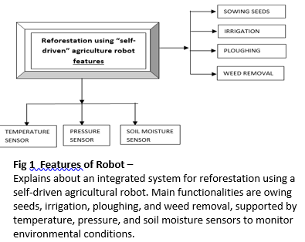

The picture represents an auto-moving agricultural robot designed for reforestation. The innovative system comprises several functions, including seed sowing, irrigation, ploughing, and weeding. The robot has sensors to check temperature, pressure, and soil moisture and hence adjust according to environmental conditions. Automating all these operations promises more efficiency, accuracy, and cost-effectiveness in the process of reforestation. This technology could really help hasten the rehabilitation of clear-cut areas and also lessen dependence on manpower, minimizing the human footprint in the process.

**CHAPTER-2**

**LITERATURE SURVEY**

**01) Vision-based Planting Position Selection System for an Unmanned Reforestation Machine - Songyu Li, Morgan Rossander, Hakan Lideskog. 2024.**

**OBSERVATIONS**

The primary aim of the research paper is **obstacle detection**. The system effectively detects obstacles within specified areas , adequately approximating their positions and sizes for tree-planting operations.

1. **Plantable Region Extraction is one of the objective**. The extraction of plantable areas and planning of planting points proved effective, achieving a feasible seedling density of 3400 seedlings/ha under ideal conditions and enabling adaptation to a standard target of 2500 seedlings/ha.
2. **Adjustable Seeding Density is the feature of the developed application**. The kernel outer radius can be adjusted in real-time by a controller to adapt seeding density, addressing variations in target densities or field conditions.
3. The system demonstrated success in autonomous reforestation cycles, leveraging a vision-based planting position selection system in forest terrain for the first time.
4. The system also uses a distributed architecture with the vision module on a Jetson Xavier and the planting planner on a laptop, supported by ROS for workload distribution and scalability.
5. Plans for future development include integrating more remotely sensed data, refining algorithms to handle subsurface obstacles, and incorporating additional obstacle categories like non-plantable depressions and tree trunks.
6. As a prototype, the system demonstrates the feasibility of automated seedling planting systems, fulfilling its role as a functional showcase for future forest robotics advancements.
7. The primary aim of the research paper is **obstacle detection**. The system effectively detects obstacles within specified areas , adequately approximating their positions and sizes for tree-planting operations.

**02) Design And Implementation Of An Urban Farming Robot.**

**- Michail Moraitis ,Konstantinos Vaiopoulos , Athanasios T.Balafoutis (2022)**

**OBSERVATIONS**

1. The main objective of image stitching process was achieved after selecting the openCV library.
2. The plant identification process was evaluated by comparing the robot’s output with a ground truth dataset or expert labels. Accuracy was determined by how correctly the system could classify different plant species or types, considering factors such as environmental conditions and image quality.
3. High accuracy ensures the system can reliably identify plants in various settings and scenarios.
4. Localization accuracy is measured by determining the deviation between the robot’s predicted position of a plant and its actual position in the environment. This is crucial for ensuring that the robot can accurately navigate and interact with plants, especially in tasks like plant inspection or picking.
5. Errors in localization can lead to misidentification or missed plants, compromising the robot's performance.
6. Movement accuracy refers to the robot’s ability to reach a specific target or follow a precise path with minimal deviation. This is typically measured by comparing the robot’s actual position against the desired position after completing a movement.
7. High movement accuracy is essential for applications requiring precise placement or interaction with objects in its environment.
8. Repeatability evaluates how consistently the robot can perform the same movement under identical conditions.
9. Multiple trials are conducted, and variations in position or movement path are measured to determine the reliability of the robot's movements.
10. A high level of repeatability is vital for tasks that require the robot to perform the same action multiple times with consistent results.

# 03) Machine Learning In Applied Fruit Trees Yield Foretelling As Per Field Data And Satellite Imaging : A Case In Citrus Orchard

# - Abdellatif Moussaid, Sanaa El Fkihi, October (2022).

# OBSERVATIONS

# The final model, combining field data and spectral information, achieved very satisfactory results with an average error of no more than 0.162.

1. The approach was cost-effective, using easily collectable field data and free satellite images, making it a practical solution for farmers to gain reliable yield predictions before harvest.
2. Field data, such as irrigation, fertilization, and phytosanitary treatments, has shown to significantly improve yield prediction models. Combining these data with spectral information from satellite or UAV images creates a more cost-effective and efficient way to predict tree yield, especially in large-scale operations.
3. While spectral data (e.g., vegetation indices from satellite images) was important for estimating tree yield, it often relies on high-cost, paid satellite images, which are not accessible to all farmers. The integration of field data can help offset the cost and improve the prediction accuracy, making the process more affordable for smaller-scale farms.
4. Several studies, including those by De Ollas et al. and Vogel et al., have shown that climate variables like temperature, precipitation, and frost can significantly impact crop yield. This highlights the importance of incorporating environmental data into yield prediction models, especially in the face of climate change.
5. Research has demonstrated that both irrigation practices and balanced fertilization are critical for achieving optimal tree yields. Models that integrate these factors, along with other field data, are likely to yield more accurate predictions, underscoring the need for careful management of water and soil nutrients.
6. When only parcel information and climate data were used (column 1), the model did not perform well, with average errors not exceeding 0.43 and some parcels showing errors as high as 100%. This highlights the limitations of using only global climate data, which are not tailored to individual parcels and thus do not contribute significantly to prediction accuracy.

**04) Planting Module Design for Automating Afforestation**

**Tylek Pamwek, Szewczyk Grzegorz (2023)**

**OBSERVATIONS**

1. The paper highlights the labor-intensive nature of manual forest regeneration, which requires significant time and effort (38 man-hours/ha for manual planting). This serves as the primary motivation for developing an automated system to reduce human labor and increase efficiency in forest planting.
2. The proposed autonomous robot aims to revolutionize forest regeneration by automating the planting process. This is achieved through an innovative technology that includes a key working unit: a universal, openable dibble combined with a three-toothed shaft, which prepares the soil for planting without the need to stop the base vehicle, ensuring continuous operation.
3. The introduction of the autonomous robot for forest regeneration promises to significantly reduce the time required for planting by replacing manual labor, leading to more efficient use of resources. Additionally, the continuous operation feature of the machine reduces downtime, potentially improving the cost-effectiveness of afforestation efforts.
4. Automating forest regeneration could have positive environmental impacts by accelerating the reforestation process in areas that were previously agricultural or reclaimed. By reducing the reliance on human labor, the system can help establish sustainable forest ecosystems more quickly, contributing to carbon sequestration and biodiversity preservation.
5. While the proposed autonomous robot represents a promising solution for large-scale forest regeneration, challenges remain in terms of scalability, terrain adaptation, and system durability.
6. Future developments may include refining the robot's ability to operate in various environments, enhancing its versatility for different types of landscapes, and ensuring its long-term sustainability in the field.

**05) Application of Artificial Intelligence Technology Into Smart Farm Robot Operations**

**- Joy Iong-Zong Chen and Pisith Hengjinda**

**OBSERVATIONS**

1. The camera in the sensor control subsystem enables the robot to capture images and compare them to monitor the growth of rice plants.
2. By analyzing these images, the robot can accurately detect any diseases that may affect the rice plants, ensuring early intervention and better crop management.
3. The ultrasonic sensor measures the water level in the rice field. If the water level falls below a preset threshold, the robot can trigger the main station to pump water back into the paddy at a consistent rate, ensuring the rice plants receive the proper amount of water for optimal growth.
4. The temperature and humidity sensor helps the robot monitor the environmental conditions of the rice field. When the air temperature rises above a set threshold, the robot can instruct the main station to spray water into the air to lower the temperature, providing a more favorable environment for plant growth.
5. The soil moisture sensor ensures that the robot maintains adequate soil moisture levels for rice cultivation.
6. When the robot reaches a target location, the humidity sensor automatically lowers to the ground to take moisture readings for 30 minutes, and once the reading is completed, it moves to the next target automatically.
7. The robot can switch to manual mode using voice commands, allowing human operators to take control when necessary.
8. Additionally, the robot is equipped with an SMS notification system, enabling it to send updates on critical data like temperature, humidity, water level, soil moisture, and disease status to the operator, enhancing decision-making and farm management.

**CHAPTER-3**

**RESEARCH GAPS OF EXISTING METHODS**

**3.1 Limitations in Current Technological Advancements in Agriculture**

Despite the transformative impact of robotics, artificial intelligence (AI), and machine learning on agriculture, significant limitations hinder the widespread adoption and full potential of these technologies. These challenges emphasize the need for further innovation and refinement to address the diverse and complex demands of modern farming practices.

One of the primary limitations of current agricultural technologies is their narrow focus on isolated functions. Many systems are designed to perform specific tasks, such as obstacle detection or basic planting mechanisms, without addressing other critical aspects of farming. Soil preparation, for example, is an essential step for ensuring optimal seed placement and crop growth. Yet, most systems lack the ability to analyze soil quality and make necessary adjustments, leaving this crucial stage inadequately addressed. Similarly, while some technologies can measure soil moisture, their ability to regulate precise irrigation levels based on real-time data is limited. This results in inefficient resource utilization and suboptimal crop performance. To maximize their impact, agricultural systems must evolve to encompass a broader range of functions, including comprehensive soil and water management solutions.

Another significant challenge lies in the adaptability of planting mechanisms to different soil types and terrains. Many existing systems rely on specific tools, such as dibbles with three-toothed shafts, which may be effective in certain soil conditions but struggle in others. Soil properties, including texture, composition, and moisture retention, vary widely across regions. Tools optimized for one soil type may fail in sandy, clayey, or rocky terrains, limiting the usability of these technologies in diverse agricultural landscapes. The lack of versatility in planting mechanisms reduces their applicability and effectiveness, particularly in regions with challenging soil conditions. Addressing this limitation requires the development of planting tools capable of adapting to a broader range of soil properties and terrains, ensuring that they remain effective in various agricultural settings.

A further limitation is the design focus of many advanced agricultural technologies, which are often tailored for small-scale urban gardens. These systems perform exceptionally well in controlled environments, such as urban gardens or hydroponic setups, where conditions are stable and predictable.

However, they face significant scalability and robustness challenges when applied to large-scale rural farms or forested areas. Transitioning these systems to rural settings requires significant modifications to address the complexities of large-scale operations, such as uneven terrain, diverse crop needs, and unpredictable weather conditions. Without these enhancements, the broader potential of these technologies for large-scale agricultural and reforestation projects remains unrealized. Developing systems with scalability and environmental adaptability is essential to unlock their full potential in diverse farming environments.

The inadequate integration of advanced analysis techniques also limits the effectiveness of current systems. Accurate crop prediction and recommendation require combining multiple data sources and employing sophisticated analytical models. While historical data provides valuable insights into long-term trends, relying solely on this static information is insufficient. Historical data often fails to account for abrupt environmental changes, such as unexpected weather events, pest infestations, or disease outbreaks. Many current systems lack the ability to integrate dynamic, real-time inputs with historical data, reducing their adaptability and accuracy. To address this gap, agricultural technologies must incorporate advanced machine learning models capable of synthesizing live environmental data with historical trends, enabling more resilient and responsive systems.

The absence of real-time data integration further compounds these limitations. Real-time monitoring of environmental conditions, such as temperature, humidity, soil moisture, and atmospheric pressure, is critical for making informed decisions. Systems with real-time data integration can dynamically adjust irrigation, fertilization, and other key parameters in response to changing conditions. Unfortunately, many current systems fail to integrate real-time data effectively, limiting their ability to address the immediate and specific needs of farmers. This deficiency reduces their effectiveness in real-world scenarios, where conditions can change rapidly and unpredictably. Enhancing real-time data collection and integration capabilities will significantly improve the adaptability and utility of these technologies in modern farming.

Sensor-based monitoring, although a significant advancement, also faces limitations in achieving comprehensive and integrated environmental monitoring. Current systems often focus on individual parameters, such as soil pH or temperature, without considering the interplay between multiple factors that influence crop health and growth.

This fragmented approach restricts their ability to provide actionable insights and comprehensive solutions. Developing systems that can seamlessly integrate and analyze data from multiple sensors will enable a more holistic understanding of crop health and environmental conditions, improving decision-making and resource management.

Finally, the over-reliance on historical data remains a critical limitation of existing agricultural technologies. While historical data is valuable for identifying trends and patterns, it does not account for sudden or unpredictable events, such as droughts, floods, or pest infestations. Systems that depend solely on historical data lack the flexibility to adapt to unforeseen circumstances, making their predictions and recommendations less reliable. By integrating real-time data alongside historical trends, agricultural technologies can enhance their accuracy and relevance, ensuring they remain effective in dynamic and uncertain conditions.

Addressing these limitations will require a concerted effort to innovate and refine existing technologies, ensuring they meet the diverse and complex demands of modern agriculture. By expanding their scope, improving adaptability, and integrating advanced analysis techniques, agricultural technologies can evolve into comprehensive solutions that enhance productivity, sustainability, and resilience.

**3.2 Urban Garden Focus and Scalability Issues**

A prominent limitation of many advanced agricultural technologies is their emphasis on small-scale urban gardens. While these systems are highly effective in controlled environments, such as rooftop gardens or hydroponic setups, they encounter significant challenges when scaled to large rural farms or forested areas. Urban gardens benefit from relatively stable conditions and manageable sizes, making the technologies tailored to them inherently ill-suited for the complexities of larger agricultural operations. Transitioning these systems to rural settings requires substantial modifications to handle uneven terrains, unpredictable weather, and diverse crop requirements.

The shift from urban to rural application also demands solutions for logistical challenges such as irrigation over vast fields, precise planting techniques for varying soil types, and resilience to pests and diseases. Without these enhancements, the technologies designed for urban agriculture remain limited in their scope, leaving untapped the immense potential of large-scale agricultural and reforestation projects.

To unlock this potential, developers must focus on creating scalable and environmentally adaptable systems capable of thriving in dynamic and challenging rural settings.

**3.3 Inadequate Integration of Advanced Analysis Techniques**

Modern agriculture increasingly relies on data-driven decisions to optimize productivity and sustainability. However, the integration of advanced analysis techniques remains a significant challenge for current systems. Accurate crop predictions and recommendations require synthesizing diverse datasets, including soil composition, weather forecasts, pest patterns, and historical trends. Despite this need, many systems overly depend on historical data, neglecting the importance of real-time inputs and predictive modeling.

While historical data provides insights into long-term agricultural trends, it often fails to address abrupt environmental changes like unexpected droughts, floods, or pest outbreaks. These sudden events can drastically impact crop yields, rendering static models ineffective. Advanced analytical techniques, such as machine learning algorithms, must incorporate live data streams and adapt dynamically to evolving conditions. By combining real-time and historical data, agricultural technologies can enhance their predictive accuracy and become more responsive to environmental changes, fostering resilience in farming practices.

**3.4 Absence of Real-Time Data Integration**

The integration of real-time data is fundamental to building adaptive agricultural systems capable of responding to rapidly changing conditions. Despite this, many current technologies fall short in incorporating real-time monitoring capabilities. Parameters such as soil moisture, temperature, humidity, and atmospheric pressure need continuous observation to inform decisions on irrigation, fertilization, and pest management.

Real-time data empowers systems to dynamically adjust operations, such as modifying irrigation schedules during a heatwave or deploying pest control measures when infestations are detected. Without this capability, technologies lack the agility to address immediate challenges faced by farmers. For example, static systems may over-irrigate fields during unexpected rainfall, leading to resource wastage and crop damage. Enhancing real-time data integration will significantly improve the precision, efficiency, and reliability of agricultural technologies.

**3.5 Limitations in Sensor-Based Monitoring**

Although sensor-based monitoring has revolutionized agriculture, it still faces significant limitations in providing comprehensive environmental assessments. Current systems often focus on isolated metrics, such as soil moisture or temperature, without integrating these parameters into a unified analysis. This fragmented approach restricts the ability of systems to account for the complex interactions between various environmental factors that influence crop health.

For instance, while soil moisture data may indicate a need for irrigation, ignoring other factors like ambient temperature or rainfall predictions could lead to overwatering and soil degradation. Developing advanced monitoring systems capable of synthesizing data from multiple sensors is essential for delivering holistic insights. These integrated systems can provide actionable recommendations that optimize resource utilization while maintaining ecological balance, addressing the multifaceted challenges of modern farming.

**3.6 Over-Reliance on Historical Data**

The dependence on historical data is another critical shortfall in current agricultural technologies. Historical datasets are invaluable for understanding trends, such as seasonal crop yields or pest behaviours. However, they lack the flexibility to accommodate unpredictable events, such as extreme weather or sudden pest outbreaks, which are becoming more frequent due to climate change.

Systems reliant solely on historical data are often unable to adapt to real-time challenges, resulting in inaccurate predictions and suboptimal decision-making. For example, a system predicting irrigation needs based on past rainfall patterns may fail during an unexpected drought, leaving crops vulnerable to water stress. Integrating real-time data streams into predictive models is crucial for addressing these limitations. This hybrid approach enhances the relevance and reliability of agricultural technologies, ensuring they remain effective in dynamic and uncertain conditions.

By addressing these interconnected limitations, agricultural technologies can evolve into robust, adaptive solutions that cater to the diverse needs of farmers, enhancing productivity, sustainability, and resilience in the face of global agricultural challenges.

**3.7 Path Forward**

To overcome the limitations currently hindering the effectiveness and adoption of advanced agricultural technologies, future developments should focus on creating more integrated, adaptable, and data-driven systems. These advancements will enable agricultural robotics and precision farming technologies to address diverse challenges, enhance productivity, and foster sustainability.

**3.8 Integrated Multifunctional Systems**

Future agricultural technologies must integrate multiple functionalities into a single cohesive system. This integration should encompass essential farming activities such as soil preparation, irrigation, weeding, and planting, ensuring seamless operation from start to finish. For instance, equipping robotic vehicles with tools capable of analyzing soil quality and making adjustments before sowing can address a critical gap in current practices. Similarly, combining automated irrigation systems with precision water delivery based on real-time soil moisture levels can reduce resource wastage and optimize crop growth. By addressing all stages of the agricultural process, these systems can provide a comprehensive solution to modern farming challenges.

**3.9 Adaptability to Diverse Soil Types and Terrains**

Designing systems that can operate effectively across various soil types and terrains is paramount. Robust and adaptable planting mechanisms should be developed to accommodate diverse conditions, from sandy to clayey soils and flat to uneven terrains. Such versatility will expand the applicability of these technologies beyond controlled environments, enabling their deployment in large-scale rural farms and reforestation projects. For reforestation efforts, systems must also account for variations in tree species, seed sizes, and planting depths to maximize ecological impact.

**3.10 Advanced Analytical Techniques**

The integration of machine learning models capable of utilizing both historical and live data is critical for enhancing the accuracy and reliability of crop prediction and recommendation systems. Advanced algorithms should analyze environmental data, historical trends, and predictive models to offer tailored solutions for specific conditions.

These techniques can improve decision-making by providing farmers with actionable insights, such as identifying optimal planting times, predicting pest outbreaks, and recommending suitable crops based on evolving environmental factors. Continuous learning capabilities will enable these systems to adapt and refine their recommendations over time, further increasing their value.

**3.11 Real-Time Sensor Integration and Monitoring**

Real-time data collection and dynamic environmental monitoring are essential for making agricultural systems more responsive to changing conditions. Incorporating advanced sensors to measure key parameters such as temperature, humidity, soil moisture, and atmospheric pressure will allow systems to provide timely recommendations and adjust operations automatically. For example, automated irrigation systems could respond instantaneously to soil moisture fluctuations, ensuring optimal water use. Similarly, real-time pest detection and weather monitoring could enable proactive measures to safeguard crops, minimizing risks of damage and loss.

**3.12 Promoting Sustainability and Resilience**

Future advancements should prioritize sustainability by integrating practices that conserve resources and reduce environmental impact. Precision farming technologies that minimize water and fertilizer wastage will play a key role in promoting sustainable agriculture. Moreover, by enhancing resilience to unpredictable weather and resource constraints, these systems can help farmers mitigate the effects of climate change. For reforestation efforts, robotic systems must be designed to ensure the long-term survival and health of planted trees, contributing to biodiversity restoration and ecosystem stability.

By addressing these areas, agricultural robotics and precision farming technologies can evolve into holistic solutions that not only enhance productivity but also ensure environmental sustainability and resilience. Such innovations will empower farmers, support large-scale reforestation initiatives, and help build a future where technology and agriculture work in harmony to meet the growing demands of a changing world.

**CHAPTER-4**

**PROPOSED MOTHODOLOGY**

**Reforestation Robot: Revolutionizing Agriculture and Reforestation**

Reforestation robots have emerged as one of the most promising innovations in modern agriculture and environmental conservation. These advanced machines combine robotics, artificial intelligence, and machine learning to tackle complex agricultural challenges, offering solutions that are both sustainable and scalable. By automating key farming tasks and incorporating data-driven decision-making, reforestation robots are transforming the landscape of farming, particularly in areas such as crop management, soil health, and reforestation efforts. This section explores the components and functionalities of the reforestation robot in greater detail, emphasizing its role in revolutionizing agriculture and promoting environmental sustainability.

**4.1 Reforestation Robotic Vehicle: The Hardware Backbone**

The reforestation robotic vehicle serves as the hardware backbone of this innovative technology. At the heart of this system is the ESP32 Node MCU, a powerful microcontroller that acts as the primary processor for the vehicle. Known for its dual-core processor, the ESP32 Node MCU allows the vehicle to handle multiple operations simultaneously. This capability is critical in performing complex tasks such as processing data from various sensors, controlling motor functions for movement and operation, and facilitating wireless communication for remote management. The dual-core architecture allows for greater efficiency, ensuring that all components of the robot work harmoniously without lag or errors.

What makes the ESP32 Node MCU particularly advantageous is its energy efficiency, which is crucial for long-duration operations in field conditions. Its cost-effectiveness and robust design make it ideal for large-scale agricultural and reforestation applications. The vehicle's operational capability in challenging environmental settings—such as varying soil conditions, uneven terrain, and unpredictable weather patterns—demonstrates its potential to be deployed widely, from urban gardens to remote forested areas. This versatility makes the reforestation robotic vehicle a key enabler of smart farming and conservation efforts.

**4.2 Precision in Planting and Maintenance**

One of the main advantages of the reforestation robotic vehicle is its ability to execute farming tasks with unprecedented precision. The vehicle incorporates specialized mechanical components that ensure accuracy and efficiency in critical agricultural functions such as planting and maintenance. For planting and seed sowing, the robot uses servo motors, which provide precise control over linear or angular movement. This is especially important in ensuring that seeds are placed at optimal depths and spacing, maximizing germination rates and overall crop yield. The servo motors allow the robot to adapt its movements with great accuracy, reducing seed waste and minimizing the need for manual intervention. This level of precision contributes to more efficient planting, improving productivity and reducing the cost of manual labour.

In addition to planting, the robotic vehicle tackles another common agricultural challenge: weed control. DC motors are used to automate the process of weeding, a time-consuming and labor-intensive task in traditional farming. The robot is equipped with sensors that allow it to identify and target weeds, using the DC motors to remove them without damaging the surrounding crops. By automating this process, the system not only reduces labor costs but also improves crop growth by ensuring that unwanted plants do not compete for water, nutrients, and sunlight.

**4.3 Sensor Integration for Real-Time Environmental Monitoring**

The integration of advanced sensors is one of the key features that make the reforestation robotic vehicle so effective in real-time decision-making. The system is equipped with a variety of sensors that continuously monitor environmental conditions, providing real-time data that is critical for efficient farming and reforestation operations. These sensors play an integral role in ensuring that the robot can make data-driven decisions, which optimize its operations and increase its adaptability to changing environmental conditions.

One of the most critical sensors is the soil moisture sensor, which constantly monitors the moisture levels in the soil. Maintaining the right level of soil moisture is essential for crop health and growth, and the sensor alerts the system when moisture levels fall below an optimal threshold. Once this alert is triggered, the robot activates its automated irrigation system, delivering water precisely where it is needed, avoiding wastage and ensuring the plants receive adequate hydration. This integration of automated irrigation helps to optimize water usage, an increasingly important factor in water-scarce regions.

The vehicle also uses DHT sensors to monitor temperature levels, which are directly linked to plant health. By tracking the temperature, the system can identify potential environmental stressors, such as extreme heat, that might affect crops. With this data, the robot can adjust its operations to mitigate the impact of such conditions, ensuring that the crops continue to grow in favorable environments.

In addition, BMP sensors measure atmospheric pressure, which can provide important information about upcoming weather changes. This data can be used to predict weather patterns, such as incoming rain or storms, allowing the robotic system to adapt its operations accordingly. For instance, the robot may increase its irrigation output in anticipation of drier weather or adjust its planting strategy in response to a sudden temperature drop. These real-time environmental insights enable the system to respond proactively, which is particularly valuable in the context of climate change and unpredictable weather conditions.

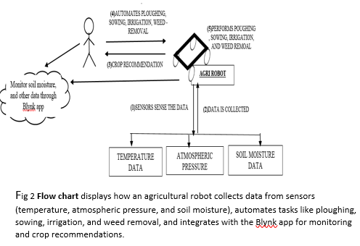

**4.4 Data Management and Remote Control via Blynk App**

All the data collected by the sensors is transmitted and stored through the Blynk app, a versatile platform that enables remote monitoring and control of the robotic vehicle. The Blynk app serves as an intuitive interface for farmers and operators, providing them with real-time insights into the environmental conditions in the fields and enabling them to manage irrigation, monitor soil health, and adjust robotic operations from a distance. This real-time connectivity ensures that farmers can make timely, informed decisions, enhancing the overall efficiency of their farming operations.

The integration of sensor data with the Blynk app makes it possible for users to remotely access detailed environmental metrics such as soil moisture, temperature, and atmospheric pressure. The app also allows for remote operation of the robotic vehicle, enabling users to control planting, irrigation, and weeding tasks with ease. This accessibility ensures that farmers can optimize their operations regardless of their location, reducing the need for constant on-site supervision.

**4.5 Expanding Applications for Agriculture and Reforestation**

The versatility of the reforestation robotic vehicle extends beyond traditional agricultural use and into the realm of environmental conservation. In reforestation efforts, the robot can automate the process of planting saplings, making it possible to scale up reforestation projects significantly. By removing the need for manual labour, the vehicle accelerates the planting process, enabling large areas of land to be reforested more quickly and efficiently. In forested regions, the robot’s ability to adapt to diverse terrain conditions, including slopes and rough terrain, allows it to operate in environments that would otherwise be challenging for human workers or conventional machinery.

Moreover, the robot’s precision in planting ensures that saplings are spaced optimally for healthy growth, while its environmental monitoring capabilities help track soil and weather conditions, ensuring that the reforestation efforts are successful. By integrating robotics with ecological restoration efforts, this technology has the potential to significantly contribute to global efforts to combat deforestation and biodiversity loss.

**CHAPTER-5**

**OBJECTIVES**

* 1. **Design and Development**

*Design and develop a robust and cost-effective robotic vehicle equipped with necessary sensors such as GPS, LiDAR, cameras, etc., actuators, and control systems for autonomous navigation and operation in diverse field conditions.  
*Incorporate a comprehensive suite of sensors for temperature, soil moisture, atmospheric pressure, and more, to collect real-time environmental data for precise crop prediction and adaptive decision-making.  
*Develop and implement robust control algorithms

to achieve accurate vehicle movement, obstacle avoidance, and safe operation in the field.  
  
**5.2 Reafforestation-Specific Objectives**  
*Design and implement autonomous seed sowing mechanisms for efficient and accurate tree and shrub planting.  
*Design and integrate systems for monitoring tree growth, including techniques for identifying and analyzing tree health, detecting diseases, and assessing the overall success of reforestation efforts.  
*Develop and implement autonomous systems for pest and disease control, such as targeted spraying or the release of beneficial insects.  
  
**5.3 Crop Prediction and Decision Support**  
*Building and training machine learning models: to provide an accurate forecast of crop yields based on historical data of the fields and actual sensor readings of the time.  
*A decision support system: be developed so that farmers may receive in-time and also accurate irrigation, fertilizers, and pest control inputs based on crop predictions coupled with the environmental conditions.  
*Decision support system can be integrated with the robotic vehicle, thus allowing a vehicle for autonomous and adaptive farming.

**5.4 Evaluation and Refinement:**  
* Conduct robust field testing for performance and reliability of the robotic vehicle with its integrated systems under natural conditions.  
Collect data and analyze data gathered from the field test and pinpoint where changes are necessary for refining system design and operations.  
Examine the impact on environmental and economic impacts that result from using a robotic vehicle in reforestation processes and agriculture.

**5.5 Disseminlation and Knowledge Transfer:**  
*User-friendly interfaces and training programs have to be developed to assist farmers in adopting and appropriately using the technology.  
Publication, conferences, and workshops are to be used to propagate research findings and best practices to ensure the wide dissemination of automated agriculture technologies. Collaboration with stakeholders (farmers, policymakers, and industry partners) has to be ensured to ensure that this technology is successfully implemented and sustained.

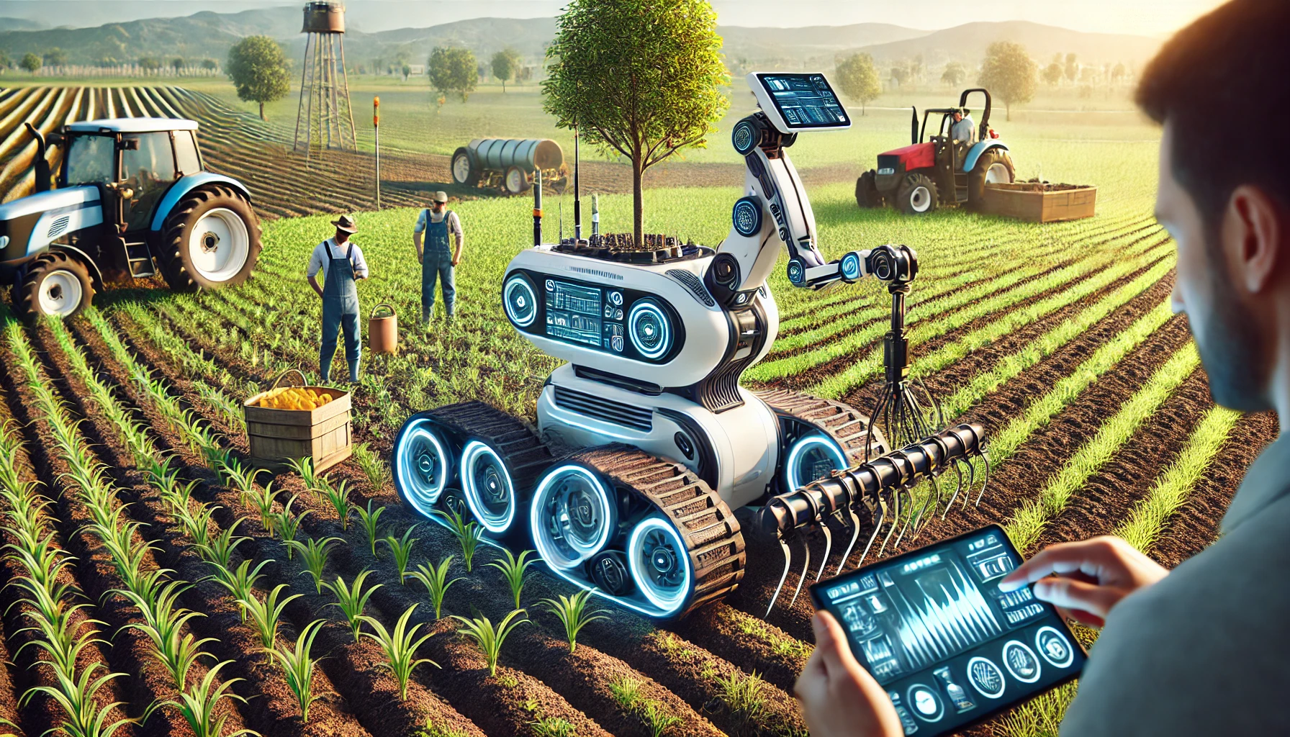

**CHAPTER-6**

**SYSTEM DESIGN & IMPLEMENTATION**

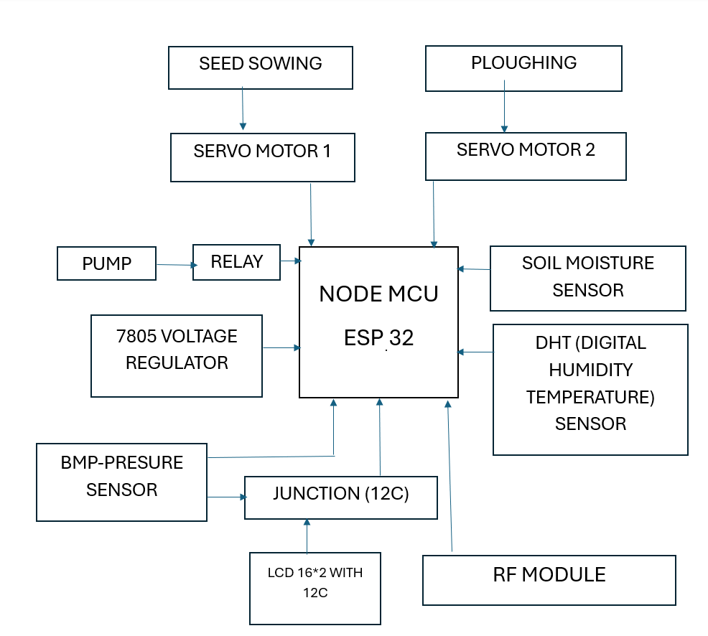

**IMPLEMENTATION**

This section explains the step-by-step implementation of the system described in the diagram, starting from hardware integration to programming and testing.

**Step 1: Hardware Setup**

**1.1 Node MCU ESP32 Integration**

* The **ESP32 (Node MCU)** serves as the central controller for the system. It will interface with all sensors, actuators, and display modules.
* Ensure proper power supply (3.3V for ESP32 and 5V for peripherals).

**1.2 Sensors Setup**

* **Soil Moisture Sensor**:
  + Place the soil moisture sensor in the soil to measure moisture content.
  + Connect its signal pin to an analog input on the ESP32.
* **DHT Sensor**:
  + Connect the DHT sensor (for humidity and temperature) to a digital pin on the ESP32.
  + Use an appropriate pull-up resistor if needed.
* **BMP Pressure Sensor**:
  + Connect the BMP sensor via the I2C junction for atmospheric pressure data.
  + Ensure SDA and SCL are correctly wired to ESP32 I2C pins (usually GPIO 21 and GPIO 22).

**1.3 Actuators Setup**

* **Servo Motors**:
  + Connect the signal pins of Servo Motor 1 (seed sowing) and Servo Motor 2 (ploughing) to PWM-capable GPIO pins on ESP32.
  + Ensure a stable power source for the servos (using the 7805 voltage regulator if necessary).
* **Pump (via Relay)**:
  + Wire the relay module to control the water pump.
  + Connect the relay signal pin to a digital output of the ESP32.

**1.4 LCD Display (16x2 with I2C)**

* Connect the LCD display to the I2C junction.
* Verify SDA and SCL are correctly linked to ESP32.

**1.5 RF Module**

* Attach the RF module for wireless communication (e.g., HC-12 or nRF24L01).
* Connect the data pin to the ESP32 and power it as required.

**Step 2: Programming**

**2.1 Setting Up the Environment**

* Install the **Arduino IDE** or **Platform IO** for coding.
* Install required libraries:
  + Adafruit_Sensor, DHT for DHT sensor.
  + Adafruit_BMP085 or similar for BMP sensor.
  + Servo for servo motor control.
  + Wire for I2C communication.

**2.2 Code Development**

* **Initialization**:
  + Initialize sensors, servos, and the relay module in the setup() function.
  + Set up I2C communication for the BMP sensor and LCD display.
* **Sensor Reading**:
  + Continuously read data from soil moisture, DHT, and BMP sensors in the loop() function.
  + Store the readings in variables.
* **Actuator Control**:
  + Implement logic to control actuators:
    - If soil moisture is below a threshold, activate the pump via the relay.
    - Use servo motors for seed sowing and ploughing based on user commands or predefined patterns.
* **LCD Display**:
  + Display sensor readings and system status on the LCD.
* **RF Communication**:
  + Send sensor data wirelessly or receive commands for actuator control.

**Step 3: Power Supply Management**

* Use the **7805 voltage regulator** to step down voltage for 5V components.
* Power the ESP32 either via USB or a separate power source with 3.3V.

**Step 4: Testing and Debugging**

**4.1 Individual Component Testing**

* Test each sensor independently and verify its output.
* Test the relay by turning the pump on/off.
* Check servo motor movements for ploughing and seed sowing.

**4.2 Integration Testing**

* Connect all components to the ESP32 and run the complete system.
* Verify that the sensors, actuators, and display are working as expected.

**Step 5: Deployment**

**5.1 Installation**

* Place the sensors in the field:
  + Soil moisture sensor in the soil.
  + DHT and BMP sensors in open air for accurate readings.
* Fix the ESP32 and other electronics in a weatherproof enclosure.
* Position the servo motors and pump for efficient operation.

**5.2 Monitoring and Maintenance**

* Monitor real-time data on the LCD or remotely via RF communication.
* Maintain the hardware by regularly cleaning the sensors and checking connections.

**Key Functionalities**

1. **Automated Irrigation**:
   * If the soil moisture is low, the pump will activate to irrigate the field.
2. **Ploughing and Seed Sowing**:
   * Servo motors perform ploughing and controlled seed sowing operations.
3. **Weather Monitoring**:
   * The DHT and BMP sensors provide environmental data for better decision-making.

**CHAPTER-7**

**TIMELINE FOR EXECUTION OF PROJECT**

**(GANTT CHART)**

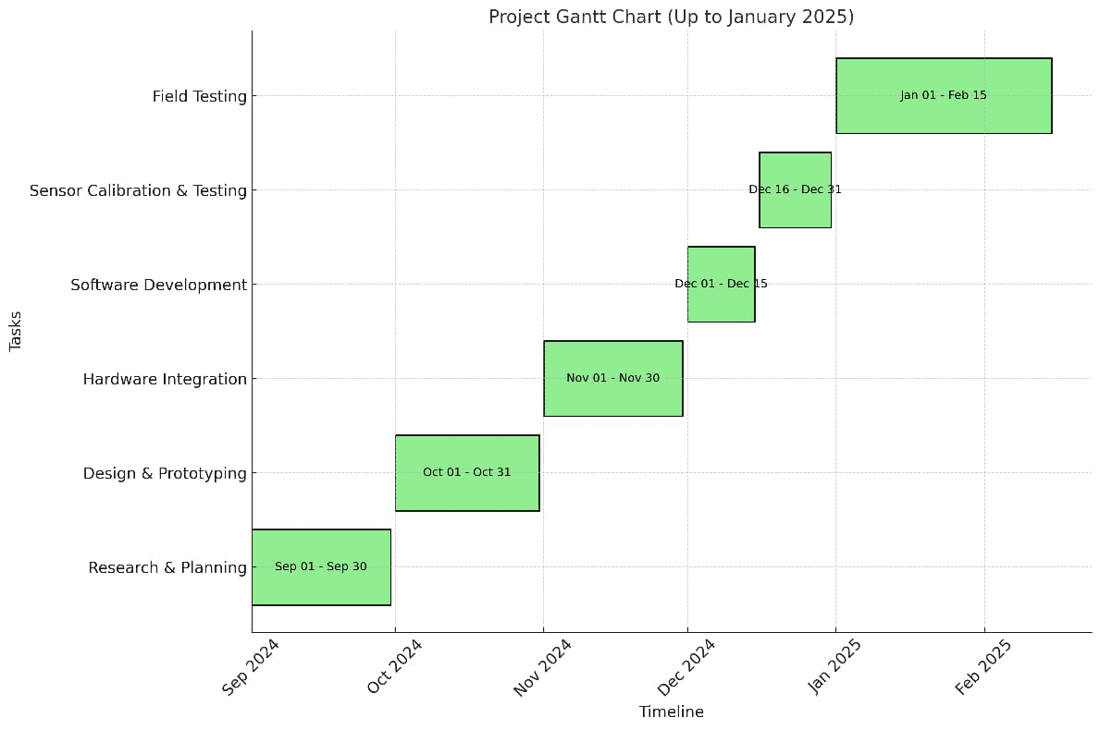

Project Timeline:

1. Research & Planning

* Start Date: September 1, 2024
* End Date: September 30, 2024
* Duration: 1 month
* Dependencies: None
* Description: This phase involves initial research and planning activities to set the groundwork for the project. It includes defining objectives, identifying requirements, and creating a project plan.

2. Design & Prototyping

* Start Date: October 1, 2024
* End Date: October 31, 2024
* Duration: 1 month
* Dependencies: Research
* Description: In this phase, the design and prototyping of the robotic vehicle take place. This includes creating detailed designs, building prototypes, and testing initial concepts.

3. Hardware Integration

* Start Date: November 1, 2024
* End Date: November 30, 2024
* Duration: 1 month
* Dependencies: Design
* Description: This phase involves integrating various hardware components into the robotic vehicle. This includes assembling sensors, actuators, and control systems to ensure they work together seamlessly.

4. Software Development

* Start Date: December 1, 2024
* End Date: December 15, 2024
* Duration: 0.5 month
* Dependencies: Design
* Description: During this phase, the necessary software for controlling the robotic vehicle is developed. This includes programming control algorithms and creating user interfaces.

5. Sensor Calibration & Testing

* Start Date: December 16, 2024
* End Date: December 31, 2024
* Duration: 0.5 month
* Dependencies: Hardware
* Description: This phase involves calibrating the sensors and testing the entire system to ensure it operates correctly. Any necessary adjustments are made to optimize performance.

**CHAPTER-8**

**OUTCOMES**

**8.1 Better productivity and Sustainability**

- The integration of robot vehicles with advanced technology and machine getting to know algorithms significantly complements the productivity and sustainability of reforestation practices.

- By using automating farming sports including ploughing, sowing, and irrigation, the gadget reduces the need for guide hard work and guarantees extra green use of resources.

**8.2 Powerful Crop Prediction**

- Using stay sensors for measuring temperature, soil moisture, and atmospheric pressure lets in for accurate crop prediction.

- System getting to know algorithms skilled on historical subject statistics assist in imparting reliable crop guidelines, consequently minimizing the probabilities of crop screw ups.

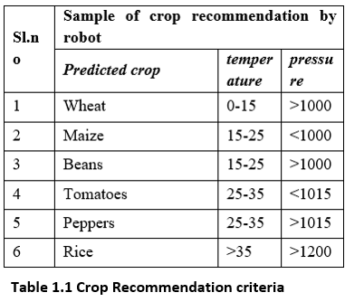

**8.3 Guide for novice Farmers**

- The device aids beginner farmers in sowing adaptive vegetation, lowering the attempt required and improving planting precision thru an automatic planting gadget.

- This help results in higher crop management and better yields, even for those with much less farming enjoy.

**8.4 Automatic Farming Practices**

- The method demonstrates the capacity for automating diverse farming practices, main to greater efficient and specific agricultural operations.

- The mixing of more than one functionalities (ploughing, sowing, irrigation) within a single robot vehicle showcases its versatility and practicality.

**8.5 Successful checking out on Rice and Wheat plants**

- The effectiveness of the proposed method became confirmed through successful tests on rice and wheat crops.

- The technique's adaptability to other vegetation shows its huge applicability and capability for huge adoption.

**8.6 Insights for destiny traits**

- The research presents valuable insights into similarly improvements in automating wooded area control and yield prediction of encouraged crops.

- Maintaining ecological balance through particular and green farming practices highlights the importance of sustainable agriculture.

**8.7 Ecological and monetary advantages**

- The automation of farming practices now not best enhances productivity however also contributes to maintaining ecological balance.

- The capability boom in agricultural output and efficiency will have a high quality effect at the economic system, specially in areas where agriculture is a major contributor to GDP.

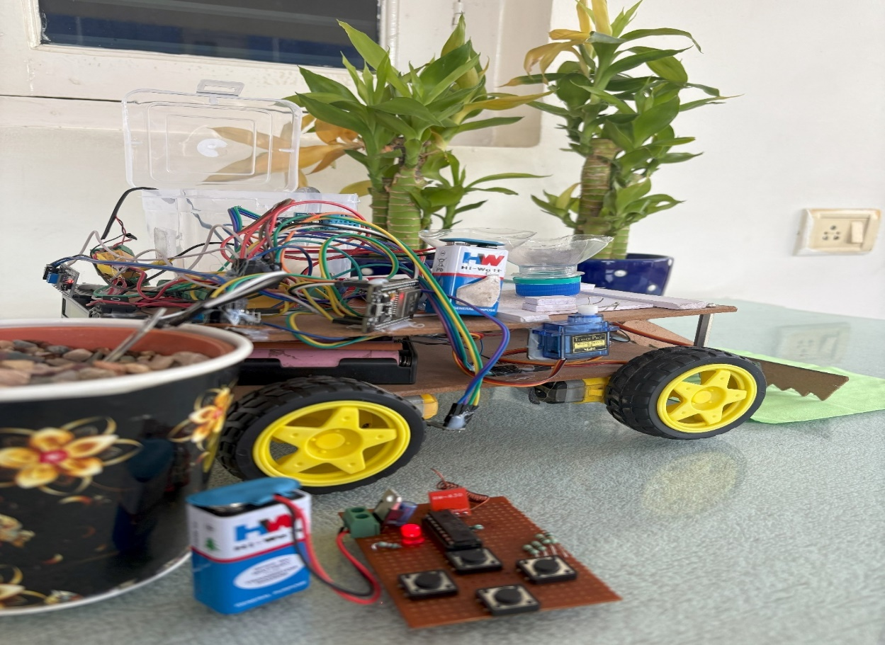**CHAPTER-9**

**RESULTS AND DISCUSSIONS**

Advanced Agricultural Automation through Reforestation Robot and IoT Integration

The integration of advanced robotics and the Internet of Things (IoT) in the reforestation robotic system is a game-changer in modern agricultural automation. By leveraging these technologies, the system streamlines several essential farming processes, including ploughing, sowing, irrigation, and weeding, thereby significantly enhancing efficiency and reducing human labour. The key to its success lies in its precision and ability to operate in real-time, making data-driven decisions based on environmental conditions and crop needs.

**9.1 Automation of Agricultural Operations**

At the core of the reforestation robotic system’s functionality is its ability to automate critical farming tasks. Ploughing and sowing, for instance, are performed with high accuracy, ensuring uniform field coverage and optimal seed placement. The robot’s servo motors provide precise control over movement, allowing the vehicle to plough the soil and sow seeds at the right depth and spacing. This precision not only enhances crop yield but also reduces seed wastage and minimizes the need for replanting.

Furthermore, weeding is automated through the use of DC motors, which help identify and remove unwanted plants that may compete with crops for resources. The automation of this labor-intensive task reduces the dependency on manual labor and contributes to a cleaner, more productive field.

**9.2 Real-Time Environmental Monitoring for Resource Optimization**

The incorporation of real-time environmental data monitoring through sensors is a key advantage of the reforestation robotic system. These sensors track critical environmental factors such as soil moisture, temperature, and atmospheric pressure, providing a comprehensive view of the field’s conditions. The data collected by these sensors is transmitted and analyzed by the system in real time, enabling adaptive decision-making.

For example, soil moisture sensors continuously monitor the moisture levels in the soil and activate the irrigation system only when necessary.

By activating the irrigation system based on real-time moisture data, the system promotes water conservation, an essential factor in regions where water resources are limited. Similarly, DHT sensors measure the temperature, providing insights into environmental changes that could affect crop health. By adjusting the system’s operations based on temperature fluctuations, the robot helps protect crops from environmental stressors.

BMP sensors also contribute by measuring atmospheric pressure, which can indicate impending weather changes, such as the onset of rain or a sudden drop in temperature. This data helps the robot adapt its operations, adjusting irrigation or other activities as necessary to maintain optimal growing conditions for crops.

**9.3 Sustainability and Resource Efficiency**

The reforestation robotic system’s ability to monitor and respond to environmental conditions not only improves crop productivity but also enhances the sustainability of farming practices. By ensuring the precise use of water, fertilizers, and other resources, the system minimizes waste and reduces the environmental impact of agricultural operations. In addition to water conservation through precise irrigation, the system also contributes to sustainable farming by reducing the reliance on chemical herbicides for weed control, since the DC motors are able to remove weeds mechanically, without the need for harmful chemicals.

The integration of IoT with the robotic system also allows for real-time monitoring and remote management through platforms like the Blynk app. Farmers can monitor sensor data, adjust irrigation schedules, and manage other operations from anywhere, enhancing efficiency and reducing the need for constant on-site supervision. This connectivity empowers farmers with data-driven insights, helping them make informed decisions that promote long-term sustainability and productivity.

**9.4 Real-Time Monitoring and User Interaction**

A key innovation of the reforestation robotic system is its ability to provide real-time monitoring and user interaction, significantly improving both the efficiency and accessibility of agricultural operations. The Blynk IoT app serves as the interface for this interaction, allowing farmers to remotely monitor the system's performance and access real-time sensor data.

This app gives farmers full visibility into important environmental parameters such as soil moisture, temperature, and atmospheric pressure, ensuring that they can make informed decisions without needing to be physically present on the farm.

Moreover, the app allows users to manage irrigation schedules, adjust settings for optimal plant care, and oversee the robotic vehicle's activities in real time. This level of control enhances operational efficiency and reduces the time and effort required for manual monitoring, especially in large-scale farming operations. The system’s real-time feedback mechanism ensures that farmers are immediately alerted to any deviations from the desired conditions, enabling quick corrective actions.

The robot’s seamless field navigation is another standout feature that contributes to the system's versatility. The robotic vehicle is designed to handle diverse terrains, including uneven surfaces and challenging agricultural conditions. This adaptability is particularly important for large or irregularly shaped fields, where traditional farming machinery may struggle. The robot’s ability to operate effectively across varied terrains enhances its reliability, ensuring consistent performance and broad applicability for different types of farming and reforestation efforts.

**9.5 Crop Recommendation and Yield Prediction**

Another critical component of the reforestation robotic system is its crop recommendation and yield prediction functionalities, which are vital tools for improving farm productivity and minimizing risks associated with crop failure. The crop recommendation system uses real-time and historical environmental data, such as temperature, soil pH, nitrogen levels, humidity, and rainfall, to recommend the most suitable crops for a given field. By analyzing these parameters, the system can predict which crops will thrive under specific environmental conditions, helping farmers make informed decisions about what to plant.

This feature is especially valuable in areas with unpredictable weather patterns or where soil quality may vary, as it takes the guesswork out of the planting process. It also minimizes the risk of crop failure by ensuring that the selected crops are well-suited to the existing environmental conditions.

Additionally, the yield prediction system uses machine learning algorithms to forecast potential crop output based on historical data and real-time environmental inputs. By analyzing patterns in data collected over time, the system can estimate how much yield a particular crop will produce under current conditions.

This predictive capability allows farmers to better plan for harvests, allocate resources, and optimize their use of fertilizers, water, and labour. The ability to predict crop yields with a high degree of accuracy also improves decision-making regarding storage, market sales, and other logistics, contributing to a more streamlined and efficient agricultural operation.

**9.6 Technological Advancements and Component Efficiency**

The success of the reforestation robotic system is largely due to the advanced technologies and efficient components that power its operations. Central to the system is the NodeMCU ESP32 microcontroller, which serves as the brain of the operation. Unlike traditional microcontrollers, the ESP32 offers a dual-core processing capability, allowing it to handle multiple tasks simultaneously—such as processing sensor data, controlling motors, and managing communications. This multitasking ability ensures smooth and continuous operation, even in complex farming environments. The ESP32’s cost-effectiveness and scalability also make it an ideal solution for widespread agricultural use, where affordability and the ability to scale up are essential.

The integration of RF modules enhances the system's mobility and control, enabling the robotic vehicle to operate remotely in even difficult-to-reach areas. RF-controlled robotic mobility ensures that the vehicle can navigate across large fields, dense forests, or other hard-to-access locations, significantly improving the system’s flexibility and usability.

Moreover, the system relies heavily on servo motors for key tasks such as ploughing and seed sowing. These motors provide precise control of angular and linear movements, ensuring that seeds are placed accurately and consistently. This precision not only boosts crop yield but also reduces the likelihood of errors, minimizing the need for replanting or field corrections.

The soil moisture sensors play a crucial role in the system's smart irrigation capabilities. By continuously monitoring soil hydration levels, the system ensures that irrigation is activated only when necessary, preventing water wastage and promoting sustainable farming practices. This is particularly important in areas facing water scarcity, where efficient resource management is crucial. The system’s ability to optimize water use through real-time feedback helps preserve water resources while maintaining optimal crop growth conditions.

**9.7 Implications for Modern Agriculture**

These findings corroborate existing knowledge about the benefits of automation and IoT in agriculture. The system showcases how modular and energy-efficient solutions can significantly improve productivity and reduce labour dependency. Its adaptability to diverse field conditions and integration with the Blynk IoT app suggest broader applications for scalable smart farming solutions. This integration bridges the gap between traditional farming practices and modern technological advancements, paving the way for sustainable and efficient agricultural practices.

**9.8 Machine Learning Algorithms for Enhanced Functionality**

The system’s crop recommendation and yield prediction capabilities are powered by advanced machine learning algorithms. The Random Forest Classifier, a supervised learning algorithm, is employed for classification tasks in the crop recommendation system. This algorithm operates on the principle of ensemble learning, where multiple decision trees are trained on random subsets of data, and their aggregated outputs form the final prediction. This approach ensures high accuracy and robustness, making it well-suited for crop prediction systems.

Similarly, the Random Forest Regressor is used for yield prediction. Like its classification counterpart, this regression algorithm utilizes an ensemble of decision trees to predict continuous output variables. Its ability to handle diverse datasets and provide reliable predictions makes it an ideal choice for estimating crop yield. The system’s implementation of these algorithms is supported by robust data preprocessing techniques, including feature scaling and one-hot encoding, ensuring optimal performance and reliability.

**9.9 Conclusion**

In summary, the reforestation robotic system represents a significant advancement in agricultural automation and precision farming. By integrating robotics, IoT, and machine learning, the system addresses critical challenges in modern agriculture, including labor shortages, resource inefficiency, and crop failures. Its ability to automate essential farming tasks, provide real-time monitoring, and deliver accurate crop recommendations and yield predictions highlights its potential to revolutionize agricultural practices.

The system’s cost-effectiveness, scalability, and adaptability further emphasize its suitability for diverse farming applications, ranging from rural agriculture to urban gardening and reforestation efforts. These innovations underscore the transformative impact of technology on agriculture, fostering a more sustainable and efficient future for the industry.

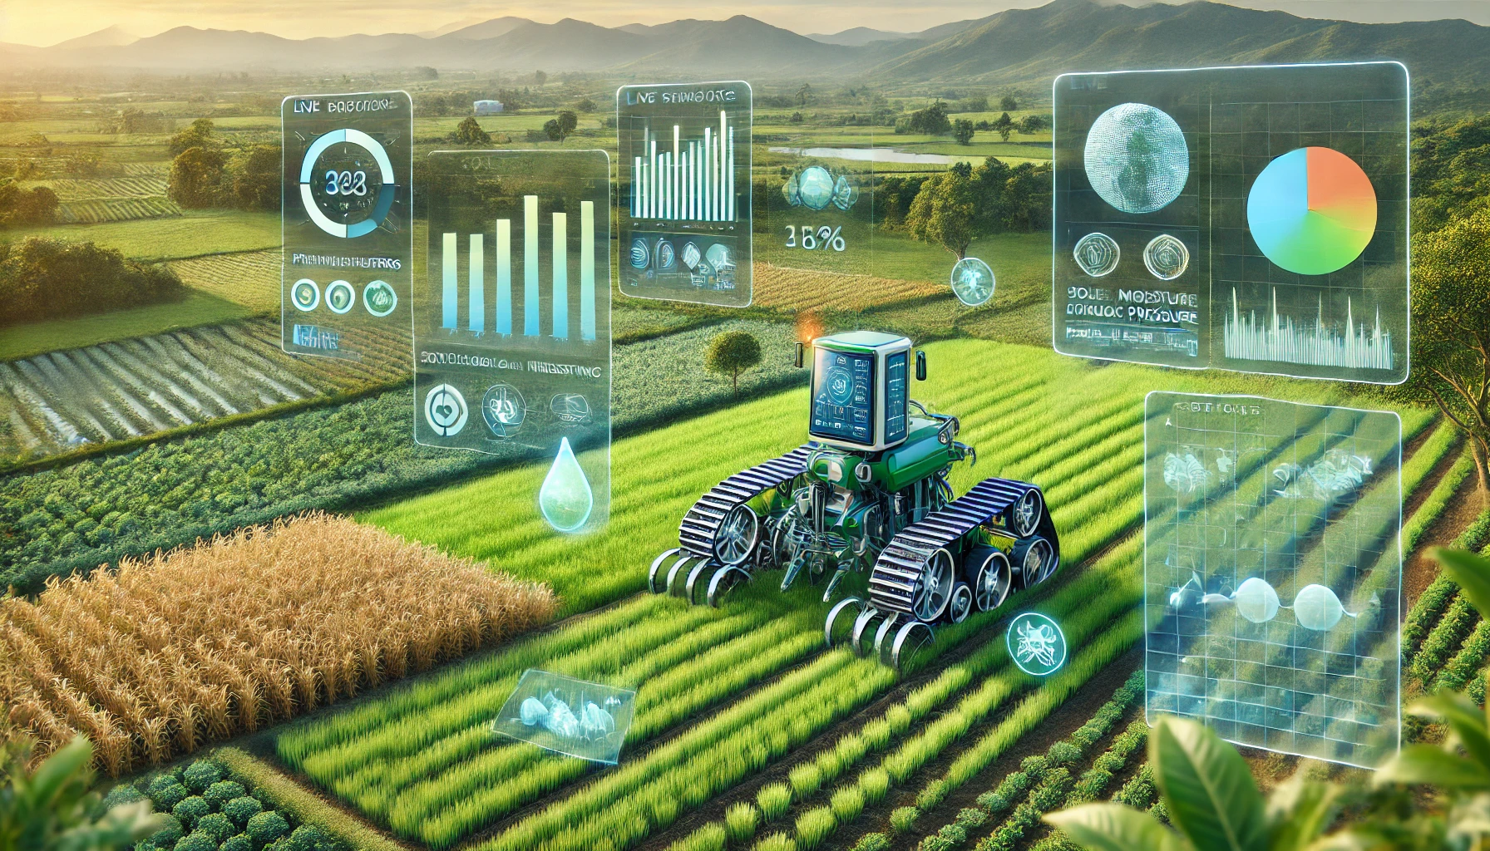

**CHAPTER-10**

**CONCLUSION**

The system successfully automated critical agricultural tasks such as ploughing, seed sowing, and irrigation, significantly enhancing precision and reducing the dependency on manual labour. This automation was achieved through the integration of advanced components, including the Node MCU ESP32 microcontroller, various sensors, and servo motors, all working in harmony to create a cost-effective and energy-efficient solution for modern farming. The Node MCU ESP32, with its dual-core processing capability and built-in Wi-Fi connectivity, served as the central hub, efficiently managing multiple concurrent tasks such as sensor data processing, motor control, and communication. This choice of microcontroller ensured seamless operation, scalability, and affordability, making it accessible to a wide range of users.

The system’s sensors provided real-time environmental data, including soil moisture levels, temperature, and atmospheric pressure. This data was crucial for optimizing resource utilization, as it enabled precise monitoring and timely interventions. For instance, the automated irrigation system activated only when the soil moisture dropped below a predefined threshold, thus conserving water and promoting sustainability. Additionally, the use of servo motors for ploughing and seed sowing brought a level of precision that manual methods often fail to achieve, ensuring uniformity in seed placement and soil preparation. The compact and efficient design of these motors further contributed to the system’s overall energy efficiency.

Another standout feature of the system was its RF-controlled mobility, which added a layer of flexibility to field navigation. This capability allowed the robot to maneuver effectively across varied terrains, making it adaptable to different agricultural conditions. The RF module’s reliable communication ensured that the robot could be controlled remotely, even in challenging environments, enhancing its usability in both rural and urban farming settings. This flexibility also made the system suitable for reforestation efforts, where accessibility and precision are often critical.

Furthermore, the integration of the automated farming system with a crop and yield recommendation module elevated its functionality. By leveraging machine learning algorithms, the system could analyze environmental conditions and suggest the most suitable crops for a given field, taking into account factors such as soil type, moisture, and climatic conditions.

This predictive capability not only improved decision-making for farmers but also mitigated the risk of crop failures by providing early warnings and tailored recommendations. The yield prediction feature further empowered farmers by offering reliable forecasts, enabling better planning and resource allocation.

Overall, this system represents a significant step forward in the realm of smart farming, combining automation, precision, and real-time data analytics to address longstanding challenges in agriculture. Its adaptability, cost-effectiveness, and energy efficiency make it a scalable solution for diverse applications, from small-scale farms to large reforestation projects, paving the way for a more sustainable and technologically advanced agricultural landscape.

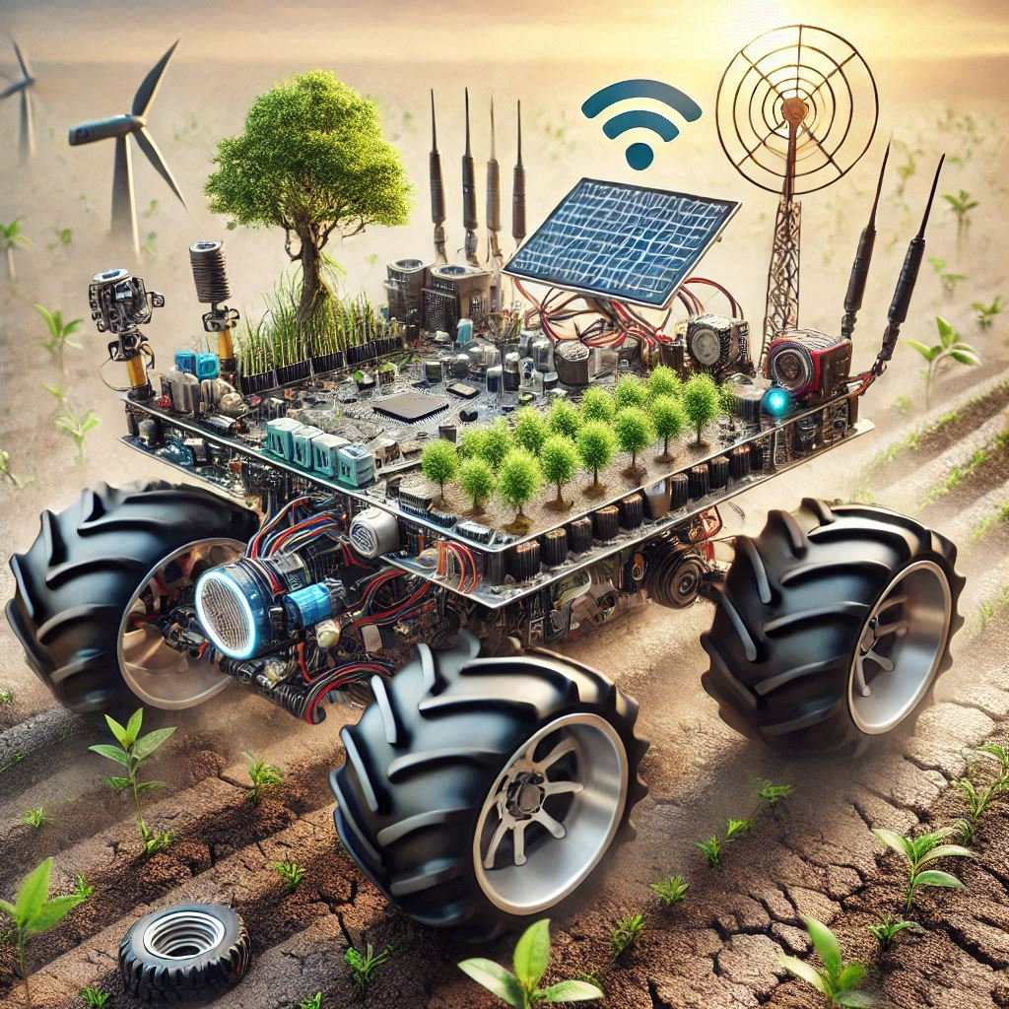

**REFERENCES**

[1] F. a. A. O. (FAO), "The State of Food and Agriculture 2020: Overcoming Water Challenges in Agriculture".

[2] P. S. a. N. G. R. Singh, "Emerging Technologies in Agriculture," Journal of Agricultural Sciences, vol. 27, p. 5, 2019.

[3] J. W. a. Q. L. Y. Zhang, "Application of Robotics in Agriculture: Challenges and Opportunities," International Robotics Journal, vol. 18, pp. 105- 121, 2021.

[4] K. V. a. A. T. B. M. Moraitis, "Design and Implementation of an Urban Farming Robot," Agricultural Robotics Quarterly, vol. 5, pp. 45-58, 2022.

[5] J. I. Z. C. a. P. Hengjinda, "Applying AI Technology to the Operation of Smart Farm Robot," Artificial Intelligence in Agriculture, vol. 4, pp. 12- 25, 2019.

[6] S. L. a. H. L. M. Rossander, "Vision-Based Planting Position Selection System for an Unmanned Reforestation Robot," Forestry Robotics Journal, vol. 12, pp. 33-45, 2024.

[7] M. S. a. P. Gupta, "Automation and IoT: Bridging technology and agriculture," Computers and Electronics in Agriculture, pp. 102-112, 2020.

[8] A. M. a. S. E. Fkihi, "Machine Learning Applied to Tree Crop Yield Prediction Using Field Data and Satellite Imagery: A Case Study in a Citrus

Orchard," Agricultural Informatics Review, vol. 8, pp. 89-102, 2022.

[9] A. R. J. a. D. S. Patil, "An Approach Towards Crop Recommendation System Using Random Forest Machine Learning Algorithm - A Review".

[10] P. T. a. G. Szewczyk, "Design of a Planting Module for an Automatic Device for Forest Regeneration," Journal of Forest Engineering and Automation, vol. 15, pp. 77-88, 2023.

**APPENDIX-A**

**PSUEDOCODE**

**Initialization**

1. Set Blynk credentials:

‣ Template ID, Name, and Auth Token.

‣ Wi-Fi credentials (SSID and password).

2. Include libraries:

‣ Wi-Fi library

‣ Blynk library

‣ Libraries for sensors DHT11, BMP180

‣ Servo control library

3. Define hardware configurations:

‣ Pins for motors, sensors, and pump.

‣ Virtual pins for Blynk communication.

4. Initialize global objects:

‣ Create instances for DHT and BMP180 sensors.

‣ Declare servos and a timer.

**Setup Function**

1. Start Serial Communication:

‣ Begin communication at 115200 baud rate.

2. Connect to Wi-Fi:

‣ Attempt to connect repeatedly until successful.

3. Initialize Blynk:

‣ connect to the Blynk cloud.

4. Setup hardware:

- Assign motor pins as outputs.

- Assign soil moisture pin as input and pump pin as output.

- Connect servos to pins

- Initialize DHT and BMP sensors.

- Set pump as OFF at the beginning

5. Initialize timer

a. Set a timed function to read and transmit data from sensors every 5 seconds.

**Loop Function**

1. Run Blynk and Timer:

- Repeat the execution of the Blynk services and the timer.

**Read and Send Sensor Data**

1. Read data from sensors

- Acquire temperature from DHT11 and BMP180 sensors.

- Acquire soil moisture status from the soil sensor.

2. Pump control:

- Soil is dry, PUMP ON

- Soil is wet, PUMP OFF

3. Transmit data to Blynk:

- Transmit DHT11 temperature to Blynk, Virtual Pin V1.

- Transmit soil moisture status to Blynk, Virtual Pin V2.

4. Serial Monitor Display:

- Print DHT11 temperature, BMP180 temperature, and pressure.

- Print soil moisture status.

**Motor Control using Blynk, Virtual Pin V0**

1.If forward movement is on

-Turn ON left and right motors in the forward direction.

2. If it stopped:

-Turn OFF all motor pins.

**Control of Servo via Blynk**

1. Servo 1 Control (Virtual Pin V7)

- Move Servo 1 to position 150° when input is 0.

- Move Servo 1 to position 0° when input is 1.

2. Servo 2 Control (Virtual Pin V8)

- Move Servo 2 to position 90° when input is 0.

- Move Servo 2 to position 0° when input is 1.

**APPENDIX-B**

**SCREENSHOTS**

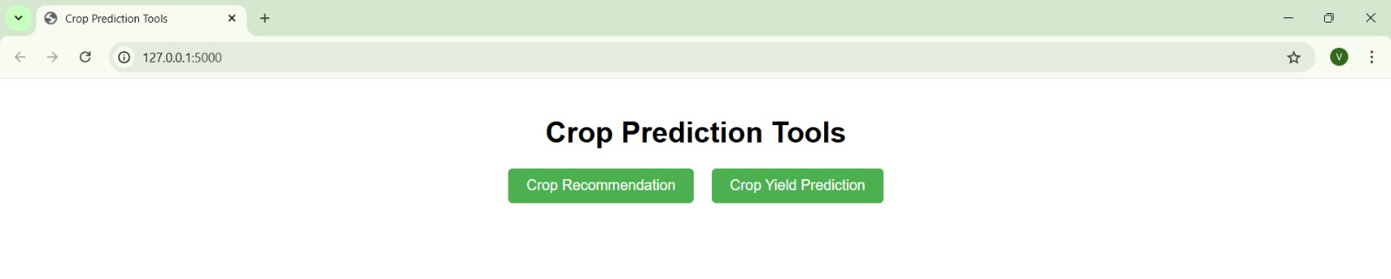

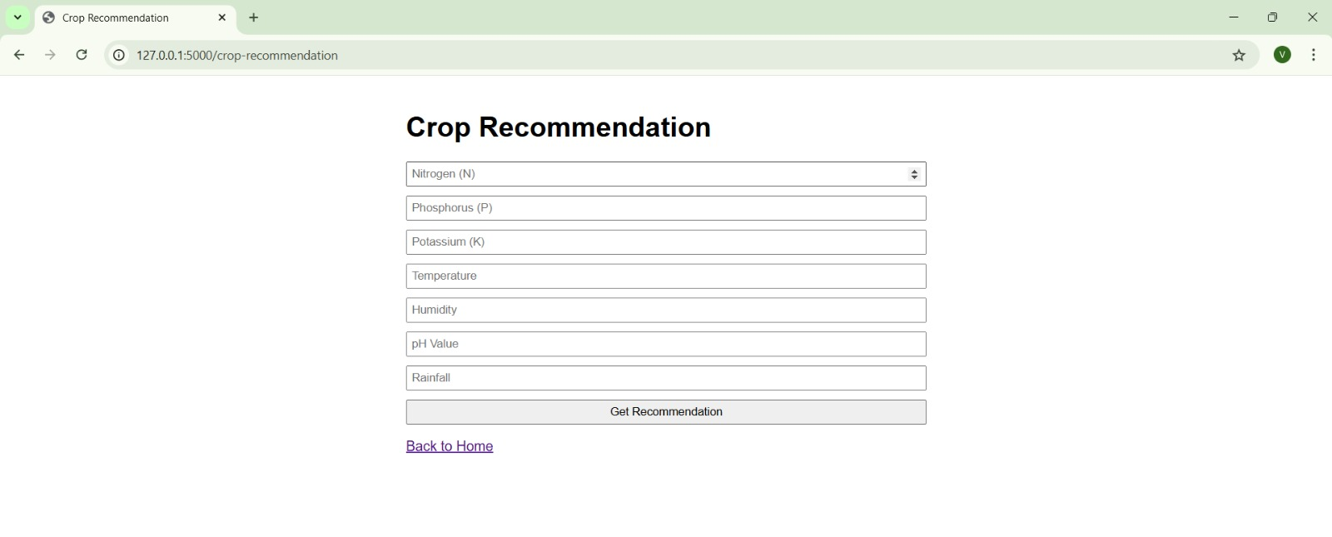

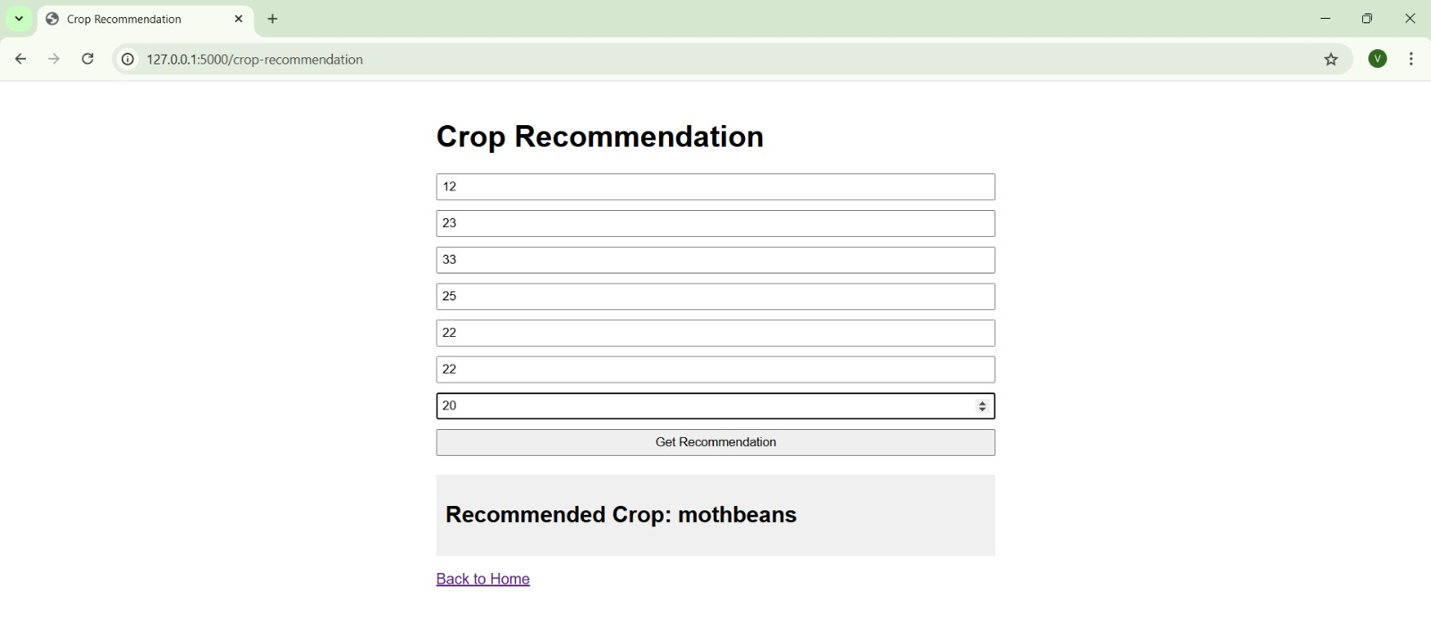

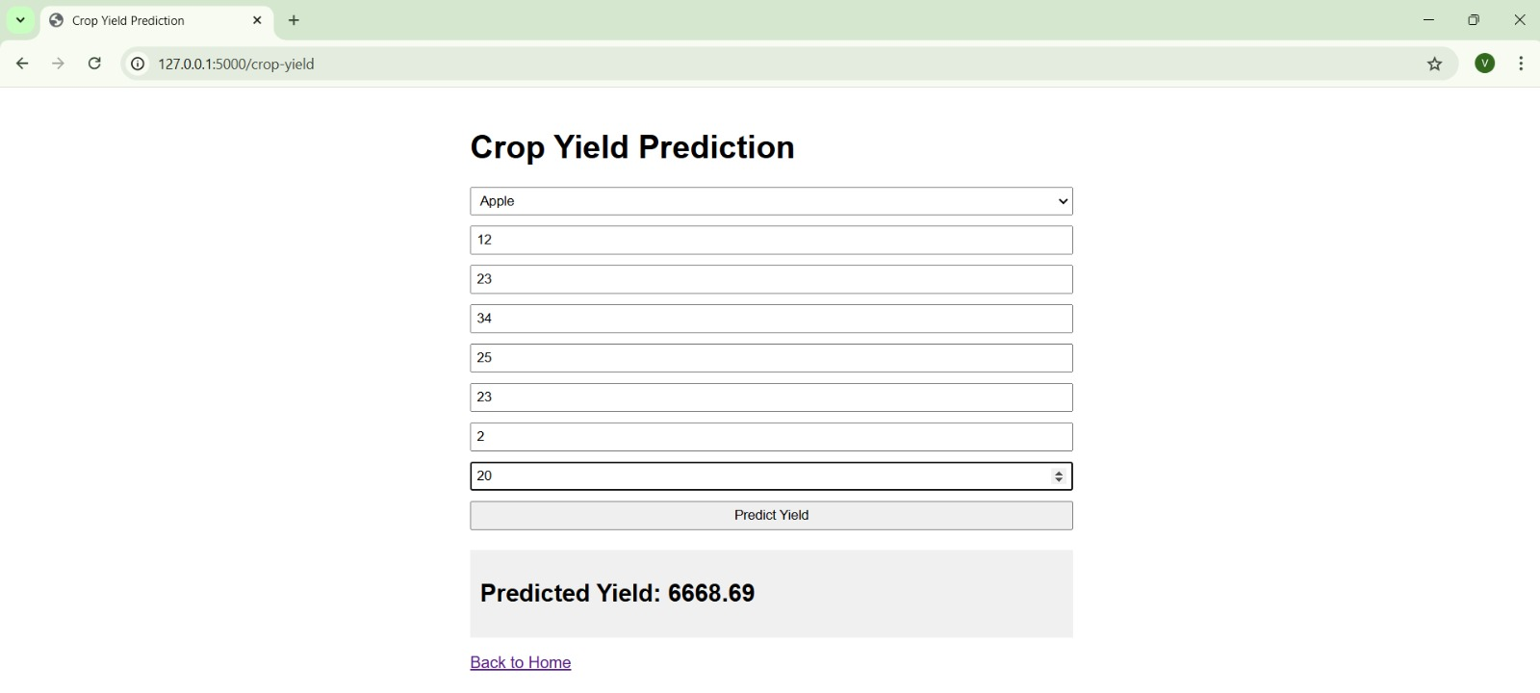

**APPENDIX-C**

**ENCLOSURES**

1.Journal publication/Conference Paper Presented Certificates of all students.

2. Include certificate(s) of any Achievement/Award won in any project-related event.

3. Similarity Index / Plagiarism Check report clearly showing the Percentage (%). No need for a page-wise explanation.

4. Details of mapping the project with the Sustainable Development Goals (SDGs).



The most accurate mapping to the Sustainable Development Goals (SDGs):

**1. Zero Hunger (SDG 2)**

- Impact: Enhancing productivity and sustainability in reforestation and farming practices can lead to increased food production and improved food security, directly addressing hunger issues.

**2. Decent Work and Economic Growth (SDG 8)**

- Impact: By increasing productivity and reducing labour costs, the project can contribute to economic growth and create decent work opportunities for farmers.

**3. Responsible Consumption and Production (SDG 12)**

- Impact: Implementing sustainable farming practices promotes responsible consumption and production patterns, ensuring efficient use of resources.

**4. Climate Action (SDG 13)**

- Impact: Reducing the carbon footprint of agricultural practices through automation and sustainable methods can contribute to climate action and help mitigate climate change.

**5. Life on Land (SDG 15)**

- Impact: Reforestation and sustainable farming practices help preserve terrestrial ecosystems and biodiversity, promoting environmental sustainability.

**6. Partnerships for the Goals (SDG 17)**

- Impact: Collaborating with various stakeholders, including governments, NGOs, and the private sector, enhances the project's impact and sustainability, fostering partnerships for achieving the SDGs.